**

**March 2012**

***Version 1.4***

An EU funded project managed by the European Union Office in Kosovo

**Road Safety Strategy and Action Plan for Kosovo**

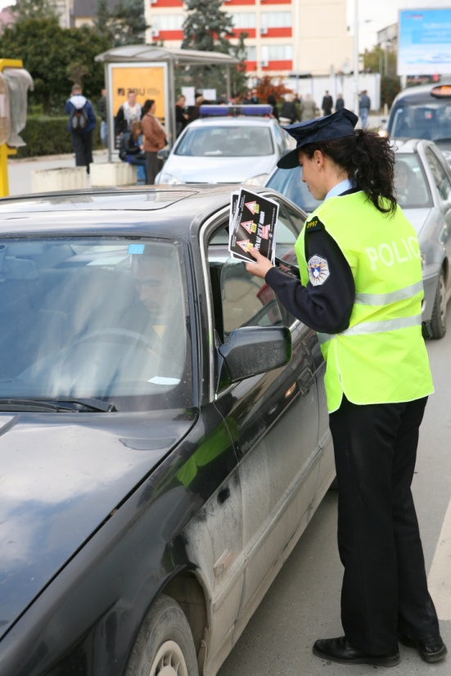

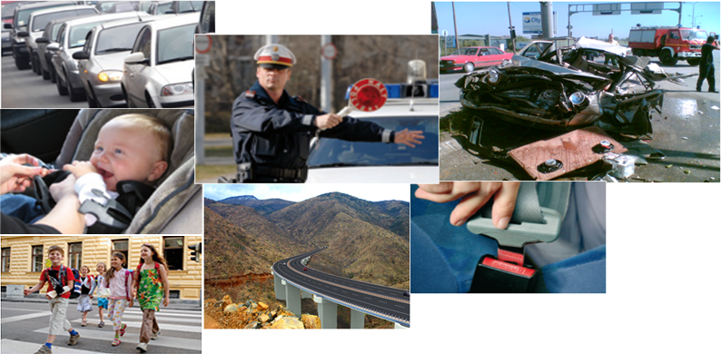



http://www.sncf-international.net/images/logo_sncfint.jpg In association with

Table of Contents

1. EXECUTIVE SUMMARY 4

1.1 Investigation and Background Analysis 4

1.1.1 Investigation phase 4

1.1.2 Analysis of accident statistics 5

1.1.3 Previous road safety programs 5

1.2 Road Safety Strategy 2012-2020 5

1.3 Road Safety Action Plan 5

1.4 Implementation 5

2. INTRODUCTION 5

3. METHODOLOGY 5

4. BACKGROUND 5

4.1 Analysis of accident data 5

4.1.1 Trends in accident 5

4.1.2 Road Safety Indicators 5

4.1.3 Involved Road Users 5

4.1.4 Injured and Killed Person by Type of Road Use 5

4.1.5 Injured and Killed Pedestrians by Age 5

4.1.6 Accidents by road type 5

4.1.7 Accidents according to road characteristic 5

4.1.8 Main Factors Causing Accidents 5

4.2 The European background 5

4.3 Previous Road Safety Strategies and Action Programmes for Kosovo 5

4.3.1 Programme on Road Transport Safety for Kosovo, RTSC 2010 5

4.3.2 Improve Capacity in the Area of Road Safety in Kosovo, World Bank, 2008 5

4.3.3 Regional Road Safety Strategy (RRSS) for SEETO Participants, SEETO, 2009 5

4.4 European and World wide Road Safety Strategies 5

4.4.1 European Road Safety Program 2000-2010 5

4.4.2 European Road Safety Program 2011-2020 5

4.4.3 United Nations Road Safety Strategy 5

4.5 Examples for European Road Safety Programmes 5

4.5.1 Austrian Road Safety Program 2002-2010, 3rd edition 2009 5

4.5.2 Austrian Road Safety Program 2011-2020 5

4.6. SWOT Analysis of the present Road Safety Situation in Kosovo 5

5. NEW KOSOVO ROAD SAFETY STRATEGY FOR THE SECOND DECADE 5

5.1 Objectives 5

5.2 Considered Alternatives 5

5.3 Recommended Road Safety Strategy 5

5.3.1 Qualitative Targets 5

5.3.2 Quantitative Targets 5

5.3.3 Targets for an Action Plan 5

6. IMPLEMENTATION 5

6.1 Project Management 5

6.1.1 Management Circle 5

6.1.2 SMART Criteria 5

6.1.2 SWOT Analysis for Implementation 5

6.2 Action Plan as Implementation Tool 5

6.2.1 Responsibilities 5

6.2.2 Timeline and Priorities 5

6.2.3 Cost and Financing 5

6.3 Monitoring and Evaluation 5

6.3.1 Performance Indicators 5

6.3.2 Monitoring the implementation of the action plan 5

6.3.3 Evaluation of the strategy and action plan 5

6.4 Compliant Institutional Prerequisites 5

6.4.1 Public Sector 5

6.4.1.1 Leading Institution 5

6.4.2 Private Sector 5

7. ACTION PLAN 5

7.1 Legend and Explanation for the Tables of Measures 5

7.2 Traffic Education and Campaigns 5

7.2.1 Road Safety Education in Schools 5

7.2.2 Lifelong learning 5

7.2.3 Awareness building Campaigns 5

7.3 Driver Education, Training and Licensing 5

7.3.1 Quality control 5

7.3.2 Dual phase driving license and Practical driving experience 5

7.3.3 Penalty (demerit) point system and withdrawal of driving license 5

7.4 Enforcement 5

7.4.1 Strengthen Enforcement Capacity of Kosovo Police 5

7.4.2 Key enforcement topics 5

7.5 Children and young road user 5

7.6 Elderly road user 5

7.7 Pedestrians 5

7.8 Bicycle, Mopeds and Motorbikes 5

7.9 Lorries and busses 5

7.10 Railway level crossings 5

7.11 Post accident care 5

7.12 Infrastructure 5

7.12.1 Infrastructure Safety Management 5

7.12.2 Speed reduction at dangerous spots and in villages 5

7.12.3 Dual carriageways with at grade crossings 5

7.12.4 Safety barriers and road marking 5

7.12.5 Road works safety 5

7.13 Vehicle safety 5

8. Annex: Requirements for a basic road accident data base for Kosovo 5

# EXECUTIVE SUMMARY

This document is a proposal for a road safety strategy and a road safety action plan with a view to improve road safety in Kosovo considerably.

For Kosovo road safety is an important issue. Its road accident performance concerning the number of killed persons is presently much closer to the standard of the European Union than to other countries in transition. Two of the main differences to the Western European Countries are that there was a significant increase of fatalities in the last decade and the number of pedestrian – representing the majority of the vulnerable road users in Kosovo - killed in a road accident are significantly too high. Also the number of children and young people is far beyond any European benchmark.

Through EU-funded programme IPA (Pre-accession Assistance) the European Union Office in Kosovo (EUOK) has contracted a project on “Support and Implementation of Transport Community Agreement (EU-TCA)”. The beneficiary entity is the Ministry of Infrastructure.

The project covers support to update and implement the multimodal transport strategy, support to the road sector, support to the rail sector and support related to TCA & regional cooperation. One of the subtasks in the road sector is to prepare and approve a strategy and action plan for road safety.

The project was contracted to EGIS International (France). The subtask road safety was conducted by Guenter Breyer, Austrian senior road safety expert.

To monitor the drafting process and to discuss and approve the strategy and action plan the Permanent Secretary of Ministry of Infrastructure established a commission, chaired by the director of the Secretariat of the Road Transport Safety Council (RTSC). The work was conducted in the time from March 2011 to March 2012,

The main elements of this document are:

* Investigation and background analysis
* Road safety strategy 2012-2020
* Road safety action plan
* Implementation

## 1.1 Investigation and Background Analysis

### 1.1.1 Investigation phase

In the investigation phase all existing framework condition and all available documents and tools have been analysed, such as:

* Databases and accident recording
* Legislative
* Enforcement strategies
* Infrastructure related road safety issues
* Organisation of Road Transport Safety Council (RTSC)
* Contacts and cooperation between stakeholders
* Relevant internal and external road safety programmes

### 1.1.2 Analysis of accident statistics

The analysis of accident statistics and their corresponding trends remains one of the central elements in the development of the new Road Safety Programme. Along with the analysis of behavioural data as well as legal institutional requirements, this forms the basis for the catalogue of measures contained in the action plan. The base for the analysis is the data publishes by the Kosovo Police for 2010.

The situation in road traffic in the recorded time from 2002 to 2010 shows a significant increase in accident and number of injured people. The number of persons killed in a road accident alternates on a high level in the last 7 years.

Remarkable is the high percentage of victims under the pedestrian and here the high percentage of injured or killed children and young people. Both figures are far away from European benchmarks.

Unfortunately only very general accident data are available and there is no information about more detailed data like accident with elderly people, accident in or outside the villages etc. Therefore an annex was added to the document, giving check-list for the minimum required road accident data to be elaborated as soon as possible.

According to the most frequently used road safety indicators the number of persons killed in relation to 1 million inhabitants is 101 and in relation to 1 million vehicles it is 500. For the last indicator it must be considered the recorded number of vehicles varies very much and that there is no official statistic covering all vehicles running with licence plates, issued in Kosovo.

### 1.1.3 Previous road safety programs

In previous times already three road safety programs for Kosovo have been developed. The last one in 2010 by the Road Transport safety Council in 2010, another 2008 by the World bank and a third on 2009 in connection with a Regional Road safety Strategy for South Eastern European Countries.

The document contains a survey on existing road safety strategies of the United Nations and the European Union and best practices from Europe.

A SWOT analysis of the present road safety situation in Kosovo highlights the strengths and weaknesses, opportunities and threats.

## 1.2 Road Safety Strategy 2012-2020

The effect of the previous road safety strategies, mentioned above, was relatively low. On the one side there was no evident political will to take concrete measures and actions and to provide the necessary human and financial recourses to improve the road safety situation in Kosovo. On the other side there is still a very low awareness in the society for the need to change the situation.

Therefore it was decided that the present road safety strategy comprises clear targets for a road safety policy. These targets should be ambitious and reasonable. Ambitious with a view to what happens currently in other, better performing, countries and reasonable with regard to having a realistic chance to reach these targets with some reasonable efforts. The time span for the policy targets should be also in line with the relevant activities in other countries and was thus appointed until to the end of this decade (2020).

To realise these targets it was evident that it requires a list of thoroughly selected concrete measures for implementation. Such an action plan is also part of the strategy and is covered with this programme.

**Qualitative Targets**

In the field of road safety Kosovo should become one of the best performers in the West Balkan Countries.

Kosovo should approach to the midfield of the EU Countries

**Quantitative Targets**

Reduce the number of fatalities by 50% until 2020

Reduce the number of injured road users by 20% until 2020

Reduce the numbers of all accidents by 10% until 2020

**Targets for an Action Plan**

An action plan is part of the road safety programme will be submitted to the political level together with the strategy.

## 1.3 Road Safety Action Plan

The action plan contains concrete measures that must be transformed into actions. The measures cover the full area of road safety, such as human behaviour, enforcement, infrastructure- and vehicle- safety and post accident care. All measures should take into account the specific situation in Kosovo and consider best practices from other countries. The action plan includes priority ranking and cost estimation for each individual action and determines which organisations are involved and which organisation has the lead in the implementing process.

The action plan consists of 12 priority areas witch overall 130 concrete road safety measures.

The priority areas are the following:

* Traffic education and campaigns
* Driver education, training and licensing
* Enforcement
* Children and young road user
* Elderly road user
* Pedestrians
* Bicycle, Mopeds and Motorbikes
* Lorries and busses
* Railway level crossings
* Post accident care
* Infrastructure
* Vehicle safety

The action plan is primarily outlined for a time-frame until 2015.

As it is evident that the availability of accident data, other statistical information, and results from survey and in depth analyses is presently very limited the highest priority stands for all those measures which shall improve this situation. These 24 High-Priority Measures should start as soon as possible and be finished by the end of 2013.

The majority of measures are 94 Short Term Measures. Some of them should also start as soon as possible. The last ones should start before the end of 2015. A further breakdown of the priorities doesn’t give much sense as progress in data acquisition and progress in improving institutional prerequisites cannot be estimated now.

The third priority range covers 12 Mid- and Long-Term Measures that should start 2015 and after. For this period after 2015 new additional measures will be necessary. The nature of and details about these measures can only be determined after a first evaluation procedure.

## 1.4 Implementation

Road safety work should be managed like any industrial production process: Following sound assessment of problems and setting of ambitious – yet achievable – numerical targets, the development and implementation of measures should be continuously monitored and their effects on road safety evaluated. Only such regular quality control can ensure continuous progress to achieve the allocated targets.

In an additional SWOT analysis the present framework conditions for implementing the strategy and action plan are highlighted. The most important results are that many things improved in the last years and that there is a rising potential of better educated and motivated actors in the field of road safety, both in the public and the private sector. Another advantage is that the availability of sufficient budget alimentation for implementing the measures is not the big issue. The biggest problems come from the present hierarchic administrative structure with low motivation and willingness to creativity, low efficiency and quality standards. Another weakness is the too small potential of well educated engineers or academics in other fields related with road safety with good knowledge of foreign languages. An additional weakness is the absence of non-governmental and non-profit organisations in the field of road safety.

According to a cost estimation less than € 500.000.- will be needed per year until 2015 to implement all high and short priority actions. Additional resources of some € 150.000 - should be allocated per year for carrying out some awareness campaigns.

Even if there is no or less financial scope in the Kosovo Consolidated Budget this financial magnitude should be easily covered by additional revenues from traffic fines that should be partly earmarked for road safety work for RTSC and Kosovo Police. There is still enough potential to increase enforcement and to raise additional funds. This is a win- win situation as better enforcement also contributes directly to a better safety on the roads.

It is recommended to establish a Road Safety Fund to which the earmarked revenues from traffic fines and other possible revenues are allocated. As these financial resources are earmarked they should not be subjected to the annual variations of the General Budget. The administration of this fund should be provided by the Secretariat of the RTSC.

The Secretariat of the RTSC in the Ministry of Infrastructure is the leading institution for implementing and managing this road safety program. In this capacity it must be strengthened considerably in its personnel structure.

The Secretariat of the RTSC is also responsible for monitoring and evaluation process. Monitoring is a continuous process and follows the principals of project management. It is recommended to maintain the present Road Safety Commission as an advisory board to the Secretariat of the RTSC.

After two years, preferably after most results from the high-priority-measure-phase are available, there should be carried out an evaluation of the road safety programme by external experts. It is highly desirable that there are also local experts in the group of evaluators.

In the private sector it is suggested to establish a Road Safety Institute that concentrates existing road safety expertises and provides junior experts good education and training on the job. This institute should be a non-profit organisation which receives a basic financing by some beneficiaries (e.g. starting with the insurance industry) and which conducts projects for the public sector (e.g. investigations, studies, surveys, etc.). It could also cover education and training, e.g. for road safety auditors and inspectors. Such an institute could be established in close cooperation with the Technical University where some expertises already exist. This idea would also provide good synergy to the student’s education.

Besides such a Road Safety Institute it is recommended to support and strengthen other NGOs. First choice is to support establishing an Automobile Club, as it existed in the former Yugoslavian time and how it exists in many European countries.

# INTRODUCTION

Over 1.2 million people die each year on the world’s roads, and between 20 and 50 million suffer from non-fatal injuries. In most regions of the world this epidemic of road traffic injuries is still increasing.

Over 90% of the world’s fatalities on the road occur in low-income countries, which have only 40% of the world’s registered vehicles.

Death rates have been declining over the last four or five decades in many high income countries. Even in these countries, road traffic injuries remain an important cause of death, injury and disability.[1]

For the 53 countries of the WHO European Region the annual death toll from road traffic injury is estimated to be 129 000 (2004). In addition road crashes injure more than 2.4 million people each year. The problem is especially severe for people age 5-29 years, for whom road traffic injuries are the leading cause of death.[2]

For Kosovo road safety is also an important issue. Its road accident performance concerning the number of killed persons is much closer to the standard of the European Union than to the Eastern European Countries. Two of the main differences to the Western European Countries are that there was a significant increase of fatalities in the last decade and the number of pedestrian – representing the majority of the vulnerable road users in Kosovo - killed in a road accident are significantly too high.

Through EU-funded programme IPA (Pre-accession Assistance) the European Union Office in Kosovo (EUOK) has contracted a project on “Support and Implementation of Transport Community Agreement (EU-TCA)”.[3] The beneficiary entity is the Ministry of Infrastructure.

The project covers support to update and implement the multimodal transport strategy, support to the road sector, support to the rail sector and support related to TCA & regional cooperation. One of the subtasks in the road sector is to prepare and approve a strategy and action plan for road safety.

The project was contracted to EGIS International (France). The subtask road safety was conducted by Günter Breyer, Austrian senior road safety expert.

# METHODOLOGY

From March to June 2011 an investigation phase was conducted, analysing the existing framework conditions, documents and tools. This analysis included:

* Databases and accident recording
* Legislative
* Enforcement strategies
* Infrastructure related road safety issues
* Road Transport Safety Council (RTSC)
* Contacts and cooperation between stakeholders
* Relevant internal and external road safety programmes

From June 2011 the road safety strategy and action plan was drafted.

To monitor the drafting process and to discuss and approve the strategy and action plan the Permanent Secretary of Ministry of Infrastructure established in July 2011 a Commission, chaired by the director of the Secretariat of the Road Transport Safety Council (RTSC). Members of the following organisation have been nominated to this Commission:

* Ministry of Infrastructure (directors of the relevant departments)
* Ministry of Internal Affairs
* Ministry of Education
* Court of minor offences
* Kosovo Traffic Police
* EULEX Traffic Police
* University of Pristina, Civil Engineering department
* University of Pristina, Mechanical Engineering department
* Representative of Hospital Emergency Centre
* Representative of Fire Brigade
* Representative of Insurance Companies
* Representative of driving schools

The Commission held 8 meetings and finally adopted the strategy and action plan in March 2012 (tbc)

# BACKGROUND

## Analysis of accident data

The analysis of accident statistics and their corresponding trends remains one of the central elements in the development of the new Road Safety Programme. Along with the analysis of behavioural data as well as legal institutional requirements, this forms the basis for the catalogue of measures contained in the action plan. The base for the analysis is the data publishes by the Kosovo Police for 2010.[4]

### 4.1.1 Trends in accident

The situation in road traffic in the recorded time from 2002 to 2010 shows a significant increase in accident and number of injured people. The number of persons killed in a road accident alternates on a high level in the last 7 years.

|  |  |  |  |  |  |  |  |  |  |
| --- | --- | --- | --- | --- | --- | --- | --- | --- | --- |
| **Development of accidents 2002-2010** | | | | | | | | | |
|  | **2002** | **2003** | **2004** | **2005** | **2006** | **2007** | **2008** | **2009** | **2010** |
| **With Material Damages** | **8,126** | **4,019** | **5,097** | **11,266** | **11,413** | **12,978** | **11,313** | **14,330** | **12,594** |
| **Accident with Injuries** | **1,153** | **1,415** | **1,326** | **2,506** | **3,013** | **3,901** | **3,850** | **4,730** | **4,327** |
| **Accidents with Killed Persons** | **107** | **107** | **141** | **145** | **156** | **127** | **118** | **152** | **158** |
| **Killed Persons** | **132** | **130** | **170** | **155** | **178** | **139** | **133** | **176** | **175** |
| **Injured Persons** | **1,983** | **2,012** | **2,053** | **4,206** | **4,789** | **6,264** | **6,427** | **7,984** | **7,731** |

### 4.1.2 Road Safety Indicators

Numbers of fatalities per 1 million inhabitants and per 1 million vehicles are the most important performance indicator of road safety.

According to the newest publication of the Statistical Office of Kosovo the preliminary result of Kosovo population census 2011 is 1,733,872 inhabitants.

The number of vehicle is presently not officially recorded. Following different statements the number varies between 260.000 and 410.000 (for 2010) vehicles. Considering the different reasons for under recording the number of 350.000 vehicles seems to be a reasonable calculation basis.

For 2010 the accident performance indicators are:

|  |  |
| --- | --- |
| **Killed person per 1 million inhabitants** | **101** |
| **Killed person per 1 million vehicles** | **500** |

### 4.1.3 Involved Road Users

The table shows the number of accident for 2010, ordered by involved road users. The figures also include accident with material damage. More detailed data with accidents with injuries and with killed person are presently not available.

|  |  |
| --- | --- |
| **Involved road user (2010)** | |
|  | **All Accidents** |
| **Accident with one car involved** | 1,486 |
| **Car -Car** | 12,407 |
| **Car – Train** | 29 |
| **Car - Bicycle** | 139 |
| **Car -Pedestrian** | 962 |
| **Car –Bus – Van** | 951 |
| **Car – Truck** | 1,007 |
| **Car – Tractor** | 157 |
| **Car – Cart** | 8 |
| **Car – Motorcycle** | 204 |
| **Car -Animal** | 58 |
| **Other** | 622 |
| **TOTAL** | **18,030.00** |

### 4.1.4 Injured and Killed Person by Type of Road Use

In the table shows the distribution of accident victims by type of participation in the accident: as driver, passenger or pedestrian. The rate of killed and injured pedestrians is extremely high, compared to the European standards.

|  |  |  |
| --- | --- | --- |
| **Type of Road User (2010)** | | |
|  | **killed** | **injured** |
| **Driver** | 61 | 2936 |
| **Passenger** | 54 | 3741 |
| **Pedestrian** | 60 | 1053 |
| **Total** | 175 | 7730 |

### 4.1.5 Injured and Killed Pedestrians by Age

|  |  |  |
| --- | --- | --- |
| Pedestrians by age (2010) | | |
|  | Killed | Injured |
| 0-12 years | 11 | 335 |
| 13-18 years | 4 | 127 |
| over 19 years | 45 | 591 |
| TOTAL | 60 | 1053 |

The table shows the age-group of pedestrian, killed or injured in an accident. A more detailed differentiation of age-groups for children and age –groups older than 19 years would be desirable but is presently not available. The rate of victims under the children and young people is again extremely high, compared with the European standards. Unfortunately no figures are available for elderly people (65+)

### 4.1.6 Accidents by road type

This table shows the distribution of accident by type of road. These data refer to all accident, including accident with material damage. More detailed data with accidents with injured and with killed and the number of injured and killed person in the different road types are presently not available.

|  |  |
| --- | --- |
| **Accident by Road Type (2010)** | |
|  | **All Accidents** |
| Highway (Magistrals) | 4726 |
| Regional | 1492 |
| Town/Urban | 9788 |
| Village/Rural | 1751 |
| Other | 273 |
| **TOTAL** | **18030** |

### 

### 4.1.7 Accidents according to road characteristic

|  |  |
| --- | --- |
| **Part of the road (2010)** | |
|  | **All accidents** |
| **Straight road** | 11090 |
| **Curve** | 1353 |
| **Round-about** | 565 |
| **Junction** | 1228 |
| **Bridge** | 20 |
| **Railway** | 16 |
| **Tunnel** | 6 |
| **Other** | 3752 |
| **TOTAL** | **18030** |

This table shows the distribution of all accident by road characteristic including accident with material damage). Mire detailed data for accident with injured and killed person are not available.

### 4.1.8 Main Factors Causing Accidents

The table shows the most common factors in causing traffic accidents according to Police observations of the Kosovo Police.

## The European background

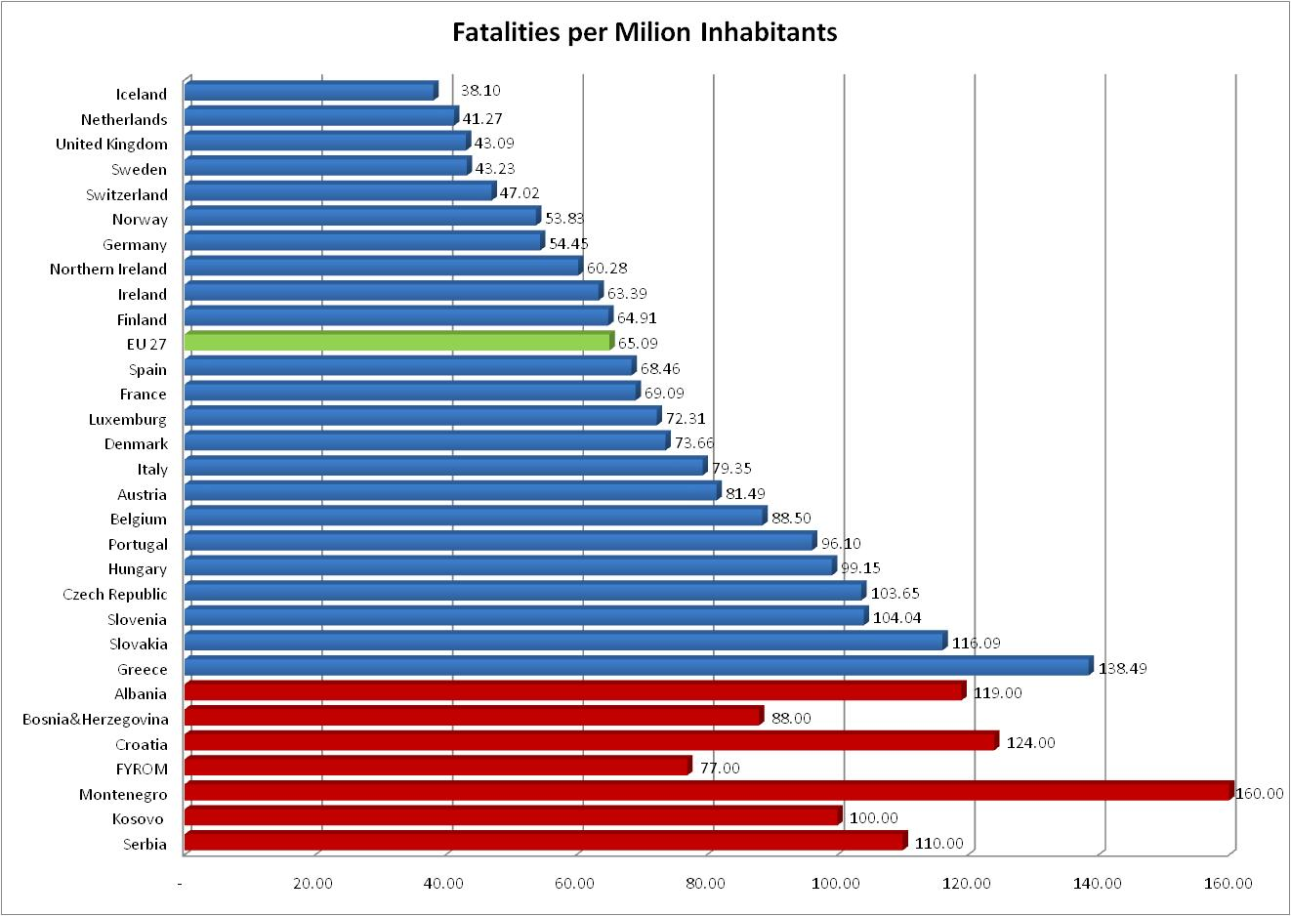

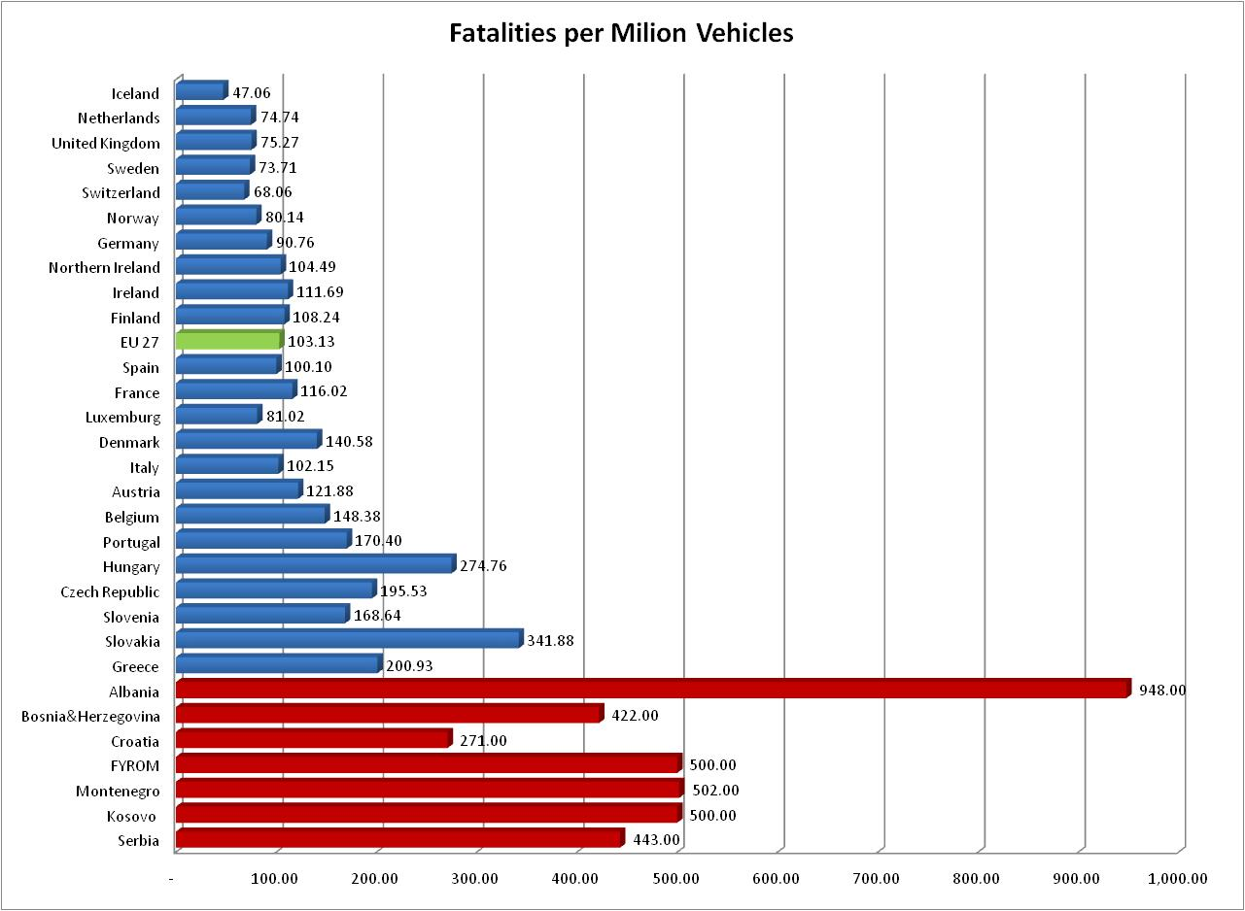

[5]

## Previous Road Safety Strategies and Action Programmes for Kosovo

### 4.3.1 Programme on Road Transport Safety for Kosovo, RTSC 2010

This programme was drafted by the Secretariat of the Road Transport Safety Council (RTSC) and was adopted in the first meeting of the Council on 9.7.2010. Taking several European Road Safety Programmes as an example this programme was drafted to reduce the negative trend in road safety in Kosovo.

The main **Goals** of the programme are:

* Reducing the number of heavy accident
* Bringing the number of accident to a European level
* Strengthen law enforcement
* Raise awareness and create a culture in road safety

The **Vision** is to close up to the EU-level to be ready for a foreseen accession to the EU.

Some **Qualitative Goals** have been defined, such as:

* + - Decrease speed (90% acceptance, 15% Tolerance)
    - Use safety belts (98% on all seats)
    - Use of helmets for motorcycles (98%)
    - Less driving under influence of alcohol (no targets)
    - Less driving without driving licence (no targets)

Additionally some **Programme Activities** have been defined, such as:

* + - Reduce Speed
    - Respect vulnerable people (pedestrian, children, elderly people)
    - No driving under influence of alcohol, drugs, narcotics etc.
    - Treatment of black spots

This Road Safety Programme was a very good start for a serious road safety work in Kosovo. It can be taken as a suitable basis for a more comprehensive strategy and action programme. It contains most of the features of such a programme as it identifies the most critical problems, affecting road safety.

Regardless the foregoing remarks the programme is primarily a statement of intention and purpose which is not sufficiently suitable for a sustainable implementation and evaluation process.

### 4.3.2 Improve Capacity in the Area of Road Safety in Kosovo, World Bank, 2008

This World Bank Public Expenditure Management Technical Assistance Grant (PEMTAG) comprised consultant services and training and was carried out by WSP inc and TRL Limited, UK.

The main tasks of the project were:

* Establishing of a road safety platform

This proposal was transposed by implementing the Road Transport Safety Council (RTSC) in the Ministry of Infrastructure

* Establishing of the Accident Information System

This was transposed by implementing the MAAP traffic accident software, including training for the Kosovo Traffic Police

* Road Safety Auditing and Engineering and Black Spot Identification and treatment

These activities were designated to be carried out by one or two working groups in line with the RTSC but have not become active

* Framework for Design and Implementation of Road Safety Campaigns

Assessing the road safety situation in Kosovo at that time the World Bank experts drafted the following statement:

These figures indicate that the price Kosovo is paying for poor road safety practices is significant and should be a cause for concern by Government. The figures represent a heavy price for Kosovo to pay, particularly as they are caused mainly by human errors of which a large proportion may be prevented by means of a coordinated, multi-agency road safety programme.

### 4.3.3 Regional Road Safety Strategy (RRSS) for SEETO Participants, SEETO, 2009

This EU-funded project (European Aid) for SEETO (South East Europe Transport Observatory) was carried out by WYG International Limited, UK. This strategy concerns all SEETO participants (Albania, Bosnia and Herzegovina, Croatia, the Former Yugoslav Republic of Macedonia, Montenegro, Serbia and Kosovo).

The Vision of the strategy is defined as follows:

Reach the level of Road Safety and establish the positive trends in continuous decline of number of fatalities and injuries as in the case of best performance EU countries.

The mission says:

− Enable the conditions for sustained development of transport and society where all citizens, and especially vulnerable road users, will be a part of safe traffic, life and everyday work,

− Establish effective road safety protective system which will involve a wide spectrum of subjects, such as: Parliaments, Governments, Ministries, different institutions, organisations, Universities, NGO’s, auto club associations, professionals, etc. where everyone will recognise their benefits and responsibilities, and

− Extend the system of responsibilities for traffic accidents, from only directly involved participants into traffic accidents, to all subjects which could contribute the decreasing of the risks of traffic accidents and their casualties.

The goal is:

The goal of the Regional Road Safety Strategy is defined with 50% reduction of road traffic accident fatalities and 30% serious injuries comparing the year 2019 with 2007.

To fulfil this goal, an integrated approach will be used based on four elements (“4E”) and some additional measures:

* Education,
* Engineering,
* Emergency and
* Enforcement
* Strengthen institutional capacities
* Improve driving licence granting system
* Improve roadworthiness of vehicles

## European and World wide Road Safety Strategies

### 4.4.1 European Road Safety Program 2000-2010

The European Commission announced in its White Paper of 12 September 2001[6] that it would establish a targeted action programme containing a set of measures to be implemented by 2010 as to reduce the number of fatalities in road accidents by 50% between 2000 and 2010.

The European Road safety Action Programme was published 2003 with the subtitle “Saving 20 000 Lives on our Roads- A shared responsibility”.[7] The goal was to halve the number of road accident victims, at that time from 40 000 in 2000 in the 15 EU-countries. Since 2004 the number of member states increased to 25, since 2007 to 27 countries.

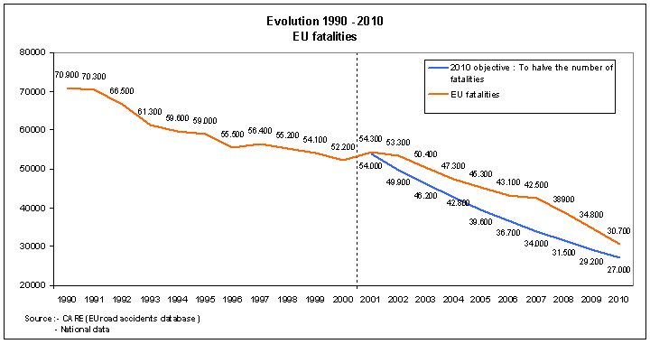

The chart shows the development of fatalities in the EU 27 and a reduction of 44% between 20000 and 2010.

Taking into account that the number of EU member states have nearly doubled in this decade, the result is very close to the target.

### 4.4.2 European Road Safety Program 2011-2020

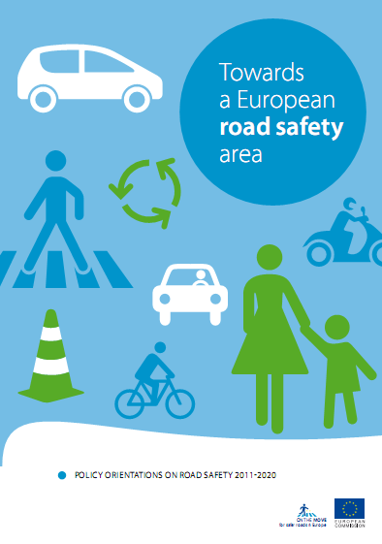The European Commission published in 2010 a new road safety programme for the next decade.[8]

The main target is again to half the overall number of road death in the European Union by 2010, staring from 2010.

Seven strategy objectives have been worked out:

* Improve education and training of road users
* Increase enforcement of road rules
* Safer road infrastructure
* Safer vehicles
* Promote the use of modern technology to increase road safety (ITS)
* Improve emergency and post-injuries services
* Protect vulnerable road users

### 4.4.3 United Nations Road Safety Strategy

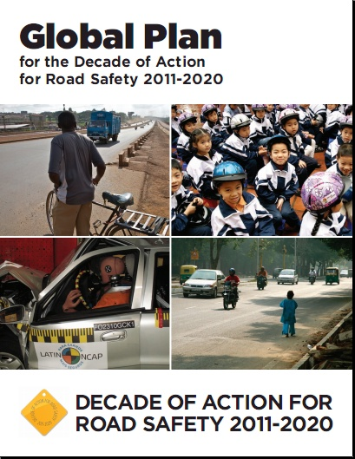Considering the enormous number of people dying each year in a road accident in the world and taking into account that this number is still rising as a result of a rapid increases in motorization without sufficient improvement in road safety strategies and land use planning, the United Nation General Assembly proclaimed a Decade of Action for Road Safety 2011-2020 on 2.Mrch 2010. This Decade was launched globally on 11 May 2011.[9]

The goal is to stabilize and then to reduce the forecast level of road traffic fatalities around the world by increasing activities conducted at national, regional and global levels. The countries are encouraged to implement activities according to five pillars:

* Road safety management
* Safer roads and mobility
* Safer vehicles
* Safer road users
* Post-crash response

## Examples for European Road Safety Programmes

### Austrian Road Safety Program 2002-2010, 3rd edition 2009

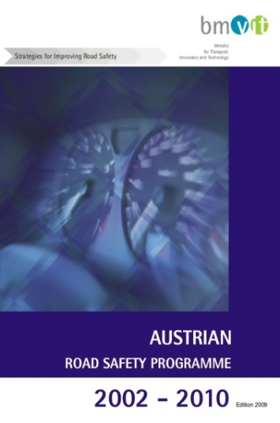

The first edition of the Austrian road safety program was publishes in 2002 and follows in its strategy the European Action Programme, a second updated edition followed in 2006 and a third in 2009.[10]

The vision was that every death and serious injury from road accident is one too many.

The target was to half the number of killed person in a road accident by 2010, compared to 2000 and to reduce the number of fatalities by 20% in this period.

In the fields of Human behaviour, Infrastructure, vehicles and Policy + Frameworks some 30 Priority Areas with some 100 specific measures have been defined. Additionally a priority system (short- medium- long-tem implementation) has been set up.

The chart below shows that the target to reduce the number of killed person has been nearly reached, also the number of injury accident showed a positive trend in the last years.

### Austrian Road Safety Program 2011-2020

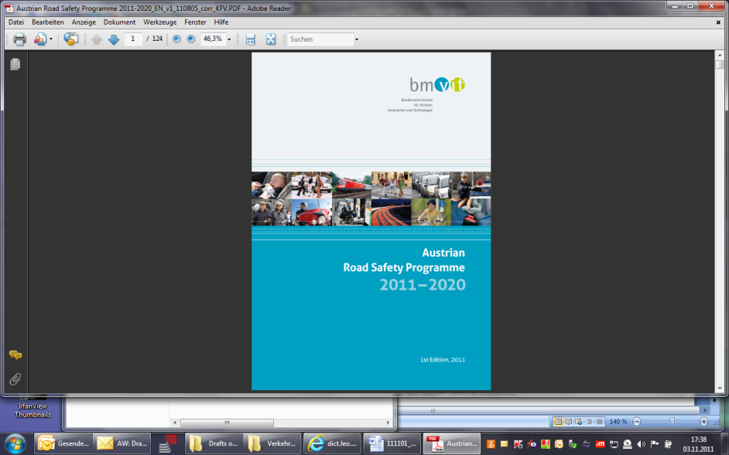On the basis of an evaluation of the previous road safety programme 2002-2010 and a status quo analysis the new road safety programme for the following decade was drafted and finally adopted by the Minister of Transport and published in January 2011. This process was accompanied and advised by the Austrian Road Safety Council.

The Philosophy of the new strategy is the “Safe System Approach”, that means all stakeholders should work together to create a safe system for all road users. This approach builds on the Swedish “Vision Zero” and the Dutch “Sustainable Safety” strategies. The safe system approach admits that accidents through human errors will always happen. Therefore the road transport system should be designed to minimize the accidents which result in fatality or serious injury. In addition to that all road users have the obligation to share responsibility, to respect the rules and to accept the limitations of the system.

The guiding principle is the ambitious target to make Austria one of the five safest countries in Europe.

The numerical targets are 50% fewer fatalities, 40% fewer serious injuries and 20% fewer injury accident by 2020.

The Action Plan consists of catalogue of over 250 measures in 17 fields of actions.

As this New Austrian Road Safety Programme is presently one of the best in Europe, it gives an example for the following Road Safety Strategy and Action Plan for Kosovo.

## 4.6. SWOT Analysis of the present Road Safety Situation in Kosovo

|  |  |
| --- | --- |
| **STRENGTHS** | **WEAKNESSES** |
| * The level of numbers of vehicles per population is still low * Essential parts of infrastructure are not in the condition to allow extensive over speeding * Kosovo population gets younger and better educated and orientates on (Western) European standards * There is a rising awareness for the risks in road transport * There are first signs that a new civil society (NGOs) will deal with the problem | * The vehicle fleet is relatively old and will not get better with admitting import of very old cars * New or rehabilitated roads become dangerous because of over speeding, insufficient equipment and maintenance * Enforcement level is low * Post accident care is insufficient * Driving too fast and risky is still tolerated by the society (no risk no fun, car as a prestige and virility object) |
| **OPPORTUNITIES** | **THREATS** |
| * Accident situation is not so far away from European standards * If there is a political will Kosovo can approach European standards * With sufficient resources the inadequate data situation can improve relatively quickly * With efficient enforcement the situation can improve rapidly * With political support the average age of vehicles could decrease considerably * Improving the social situation will increase mutual respect and valuation of personal safety * With better economic situation the vehicle fleet gets younger | * If there is no strong political commitment to improve the road safety, situation will become worse rapidly * With increasing economic wealth the number of vehicles will increase rapidly * In case of budget constraints quality of maintenance, services, enforcement, health care etc. Will get from bad to worse * Increasing brutalisation, egoism and materialism in the society prevents from building a better road safety culture * With better economic situation the number of used vehicle increases |

# NEW KOSOVO ROAD SAFETY STRATEGY FOR THE SECOND DECADE

## Objectives

Road Safety is a fundamental human right. All members of society should be encouraged and motivated to contribute to improving road safety – from decision makers to experts, from road network providers to planners, and from emergency services to road users (shared responsibility).

But to achieve this improvement, society has to question established practices, examine the feasibility and applicability of international best practices and have the courage to experiment. The United Nations Decade of Action for Road Safety (2011 – 2020) should help to also bring Kosovo a significant step forward in saving human life and avoiding human suffering.

Accidents through human error will always happen. The road transport system should be designed to minimize accidents which result in fatality or serious injury.

All users of the road transport system have an obligation to respect the rules and accept the limitations of the system.

## Considered Alternatives

The alternative to a comprehensive road safety strategy and action plan would be doing nothing or not enough. This happened with the previous road safety programs which had no or rudimentary consequences. The result will be an increasing number of injures and killed person in road accidents, causing an increasing socio-economic loss to the Kosovo society.

## Recommended Road Safety Strategy

As described in chapter 4.3 three road safety strategies had been developed for the Kosovo in the last years. On institutional level there had been some progress, like establishing the Road transport Safety Council or like establishing the MAAP road accident data base for the Kosovo Police. On the other side there was no evident political will to take concrete measures and actions and to provide the necessary human and financial recourses to improve the road safety situation in Kosovo. There is still a very low awareness in the society for the need to change the situation.

Therefore it was decided that the present road safety strategy comprises clear targets for a road safety policy. These targets should be ambitious and reasonable. Ambitious with a view to what happens currently in other, better performing, countries and reasonable with regard to having a realistic chance to reach these targets with some reasonable efforts. The time span for the policy targets should be also in line with the relevant activities in other countries and was thus appointed until to the end of this decade (2020).

To realise these targets it was evident that it requires a list of thoroughly selected concrete measures for implementation. Such an action plan is also part of the strategy and is covered with this programme.

### 5.3.1 Qualitative Targets

In the field of road safety Kosovo should become one of the best performers in the West Balkan Countries.

Kosovo should approach to the midfield of the EU Countries

### 5.3.2 Quantitative Targets

Reduce the number of fatalities by 50% until 2020

Reduce the number of injured road users by 20% until 2020

Reduce the numbers of all accidents by 10% until 2020

### 5.3.3 Targets for an Action Plan

An action plan is part of the road safety programme and should be submitted to the political level together with the strategy. The action plan contains concrete measures that can be transformed into actions. The measures should cover the full area of road safety, such as human behaviour, enforcement, infrastructure- and vehicle- safety and post accident care. All measures should take into account the specific situation in Kosovo and consider best practices from other countries. The action plan should include a priority ranking and a cost estimation for each action and determine which organisations are involved and which organisation has the lead in implementing the specific measure.

A detailed description of the action plan follows in chapter 7

# 6. IMPLEMENTATION

## 6.1 Project Management

Road safety work should be managed like any industrial production process: Following sound assessment of problems and setting of ambitious – yet achievable – numerical targets, the development and implementation of measures should be continuously monitored and their effects on road safety evaluated. Only such regular quality control can ensure continuous progress to achieve the allocated targets.

### 6.1.1 Management Circle

The figure below shows the system of an integrated management circle for road safety work.



1. The status quo analysis was carried out in the foregoing investigation phase (see chapter 3.Methodoligy)
2. The defined priority areas are the backbone of the action plan
3. General numeric targets are defined in the policy strategy. Detailed numeric targets, especially for some of the proposed measures have to be defined as soon as basic data, surveys and in depth analyses of the present situation are available
4. In the action plan 130 measures to improve road safety are listed

5. and 6. Implementation and Evaluation are tackled in this chapter

### 6.1.2 SMART Criteria

SMART Criteria are used in project management to define target agreements, here the targets of the policy strategy and the measures in the action plan.

* **Specific**: the targets in the road safety strategy and the 130 measures in the action plan are very specific
* **Measurable:** most measure can be quantified. Before that the knowledge on the present situation must be improved (accident data, surveys, in depth analyses) and performance Indicators (PI) defined
* **Accepted**: it is striven for a political commitment by the Minister of Infrastructure and the Government. The acceptance level of the road user and the population must be increased by information, awareness building, education and training and enforcement
* **Realistic**: the target and individual measures must be relevant and feasible and the main actors must be involved in the policymaking
* **Timely**: the time frame for the policy strategy must be defined and the measure must be subjected to a priority system.

What is not included in the SMART Criteria but not less important is:

* **Affordable**: the implementation of the strategy and the action plan must be financially feasible

### 6.1.2 SWOT Analysis for Implementation

|  |  |
| --- | --- |
| **STRENGTHS** | **WEAKNESSES** |
| * Kosovo has an over average young population with good education potential and increasing knowledge of foreign languages * Administrative structure for coordinating road safety initiatives is available (RTSC) * Traffic police has a good motivation and created a special department for road safety * Good progress in driver education and vehicle inspection * Rising awareness to fight corruption * For implementing action plan no large investments are needed * Additional funding can be easily obtained by strengthening enforcement and earmarking parts of the fines | * Administration still bears the markings of a developing country. Numerous state employees with low education level and poor knowledge of foreign languages are not motivated and low paid * There is mostly still the hierarchic system without individual initiatives and quality management * employees in higher responsible function frequently sit and wait until some external consultant do their work and also brings the money (negative foreign aid symptom) * Corruption is still an issue * Concerning road safety there is a very low potential of experts in this field, not in administration and not in the private sector * Poor cooperation between the administrative entities (esp. Municipalities) * In the field of road safety the private sector is still underdeveloped (local consultant, advanced training and continuous education, NGOs and non profit organisations such as road safety institute, motorist and road user associations |
| **OPPORTUNITIES** | **THREATS** |
| * Population is young and most are ambitions cosmopolitans who are willing to improve education and knowledge in foreign languages. * They have the potential for a new generation of engineers and road safety experts for the public and private sector * A better education and training will also strengthen the fitness for a future open market with the EU * By strengthening the civil society the way for NGOs and non profit organisation will smoothen | * No strong political support for implementing the strategy and action plan * Lack of support by the medias and the road user * No political will to strengthen enforcement * Cooperation between Ministries, regional administrations and municipalities doesn’t improve * Administrative system resists to any changes to improve efficiency and quality * Knowledge and expertise of local person will not improve. Depending only on external experts is expensive and not sustainable |

## 6.2 Action Plan as Implementation Tool

The action plan consists of 12 Priority Areas with overall 130 concrete road safety measures.

For each measure the main actors, involved in the implementation process, are indicated. Each measure includes a priority ranking and cost estimation (see chapter 7).

### 6.2.1 Responsibilities

Each measure indicates the most important organisations which should be involved in the implementation process**.** The first mentioned organisation should take over the lead of this activity.

Most activities concern the Ministry of Infrastructure –and here especially the Road Transport Safety Council – and the Ministry of Internal Affair-and here especially Kosovo Police Some 10 more organisation are mentioned.

### 6.2.2 Timeline and Priorities

Each measure indicates the priority for staring the individual measure. Most activities can be finished within one or two years.

The action plan is primarily outlined for a time-frame until 2015.

As it was evident that the availability of accident data, other statistical information, results from survey and in depth analyses is very limited there was the highest priority for all those measurers which shall improve this situation. These High-Priority (HP) Measures should start as soon as possible and be finished by the end of 2013.

The majority of measures are Short Term (ST) Measures. Some of them should also start as soon as possible. The last one should start before the end of 2015. A further breakdown of the priorities doesn’t give much sense as progress in data acquisition and progress in improving institutional prerequisites cannot be estimated now.

The third priority range covers the Mid- and Long-Term (MLT) Measures which should start 2015 and after. For this period after 2015 new additional measures will be necessary. The nature of and details about these measures can only be determined after a first evaluation procedure.

### 6.2.3 Cost and Financing

Each measure is allocated to a cost factor. This cost factor gives an estimate on the total cost for the individual measures. In general these cost cover all the cost for investigation, studies, scientific evaluation, surveys, study tours, information-, education- and training materials, test application, monitoring processes, co-financing of activities of other organisation when appropriate etc.

Costs for infrastructure measures are not included as they would exceed the road safety budget. In exceptional cases and depending on the available budget, money can also be used for minor infrastructural improvements, testing new materials or construction units and additional research activities. This is also valid for giving support to other organisation (e.g. Ministry of Education, Ministry of Health, Municipalities, but also NGOs etc.) when appropriate. In all these cases an evaluation of the results should be provided.

With the exception of the measure describing awareness campaigns, all measures allocate either to cost factor 1 (€ >0-10.000.-) or cost factor 2 (€ > 10.000.- - 50.000.-) Road safety campaigns are much more expensive and need a special budget allocation.

To get a reasonable estimate on the total budget, measures with cost factor 1 are calculated with an average of € 7.000.- and measures with cost factor 2 with € 30.000.-.

For road safety campaigns an annual expenditures of € 150.000.- should be considered. This amount can increase if additional funds can be raised.

The next two tables show the summary view on the road safety measures and the budget estimation.

|  |  |  |  |  |  |  |  |
| --- | --- | --- | --- | --- | --- | --- | --- |
| **SUMMARY VIEW ON ROAD SAFETY MEASURES** | | | | | | | |
| **Chapter** | **Priority Area** | **No of Meas.** | **Priority** | | | **Cost Factor** | |
| **HP** | **ST** | **MLT** | **1** | **2** |
| 4.2 | Education & Campaign | 11 | 3 | 5 | 3 | 10 | 3 |
| 4.3 | Driver Education | 10 | 3 | 7 |  | 5 | 5 |
| 4.4 | Enforcement | 25 | 5 | 14 | 6 | 11 | 3 |
| 4.5 | Children | 7 | 1 | 6 |  | 2 | 5 |
| 4.6 | Elderly People | 5 | 1 | 2 | 2 | 3 | 2 |
| 4.7 | Pedestrian | 8 | 1 | 7 |  | 3 | 3 |
| 4.8 | Bicycle & Bikes | 7 | 1 | 6 |  | 5 | 2 |
| 4.9 | Lorries & Busses | 7 | 1 | 6 |  | 6 | 1 |
| 4.10 | Railway | 5 | 1 | 4 |  | 3 | 1 |
| 4.11 | Post Accident Care | 7 | 1 | 6 |  | 3 | 4 |
| 4.12 | Infrastructure | 31 | 5 | 25 | 1 | 7 | 13 |
| 4.13 | Vehicle | 7 | 1 | 6 |  | 4 | 1 |
| **TOTAL** | | **130** | **24** | **94** | **12** | **62** | **43** |

|  |  |  |  |  |  |  |  |  |  |
| --- | --- | --- | --- | --- | --- | --- | --- | --- | --- |
| **BUDGET ESTIMATION FOR ROAD SAFETY MEASURES** | | | | | | | | | |
| **Priority Class** | **Cost Factor** | | **Total Cost in 1.000 €** | **Annual Rates in 1.000 €** | | | | | |
| Factor*) | No. | **2012** | **2013** | **2014** | **2015** | **2016** | **2017** |
| High Priority 2012-2013 | 1 | 10 | 75 | 20 | 30 | 25 |  |  |  |
| 2 | 12 | 360 | 100 | 160 | 100 |  |  |  |
| Short Term 2012-2015 | 1 | 43 | 320 | 40 | 80 | 80 | 80 | 40 |  |
| 2 | 30 | 900 | 60 | 200 | 250 | 250 | 140 |  |
| M+L-Term 2015 -2018 | 1 | 8 | 60 |  |  |  | 20 | 20 | 20 |
| 2 | 2 | 60 |  |  |  | 20 | 20 | 20 |
| **TOTAL** |  | **105** | **1,775** | **220** | **470** | **455** | **370** | **220** | **40** |
| Campaignes |  |  | 800 | 50 | 150 | 150 | 150 | 150 | 150 |
| **TOTAL with Campaignes** |  |  | **2,575** | **270** | **620** | **605** | **520** | **370** | **190** |

*) Cost estimation for individual measures: Cost Factor 1: Ø € 7.500.-

Cost Factor 2: Ø € 30.000.-

The annual budget rates for implementing the action plan between 2012 and 2015 are between € 220.000.- and 470.000.-. 2012 is only considered as a half year. From 2015 there is space for new activities according to the evaluation results.

The annual budget rates increase up to a maximum of € 620.000.- if € 150.000.- are considered annually for road safety campaigns.

Taking into account that, when establishing the Road Transport Safety Council (RTSC) (Administrative Instruction No 18/2008), an annual budget of € 1,290.134.- was allocated in the first year to the RTSC an annual budget for implementing the action plan should be reasonable and should give some financial scope for other road safety activities.

Even if there is no or less financial scope in the Kosovo Consolidated Budget this financial magnitude should be easily covered by additional revenues from traffic fines which should be partly earmarked for road safety work for the RTSC and the Kosovo Police. Presently the revenues from traffic fines in Kosovo are around € 10 mio. (The revenues in Austria with 8 mio inhabitants are over 250 mio). Comparing the number of infringements, only for speeding is some 100.000 in Kosovo and more than 4 mio in Austria. This comparison shows that there is still enough potential to increase enforcement and to raise additional funds. This is a win- win situation as better enforcement also contributes directly to a better safety on the roads.

It is recommended to establish a **Road Safety Fund** to which the earmarked revenues from traffic fines and other possible revenues are allocated. As these financial resources are earmarked they should not be subjected to the annual variations of the General Budget. The administration of this fund should be provided by the Secretariat of the RTSC.

## 6.3 Monitoring and Evaluation

The road safety strategy and action plan needs a continuous monitoring process and an evaluation of the action plan after 2 years. The leading organisation for these tasks is the Secretariat of the Road transport Safety Council.

### 6.3.1 Performance Indicators

Performance indicators help to quantify the progress of the road safety work and to set benchmarks.

As already mentioned before it is presently not possible to provide a list of feasible performance indicators. Quantifying data and information on the status quo on road safety in Kosovo are relatively poor or could not be communicated to the project. Most performance indicators have to be developed in the high-priority-action– period.

The most important performance indicators have to develop out of a much more detailed accident data base for a period of at least 3, better 5 years In the Annex there is a number of tables, showing the minimum requirements for a basic accident data base.

Other data, like use of seat belts and child restraints must be gathered from survey. Performance indicators must also be developed in the field of post accident care, enforcement, punishment of traffic law offenders etc. In all these fields it was not possible to receive reliable and comprehensive data. Another big data problem in the context of developing performance indicators in the field if infrastructure safety is the total lack of knowledge about black spots because there is no localisation reference system in the roads and location data in the accident protocols are not existing or not evaluated.

### 6.3.2 Monitoring the implementation of the action plan

Monitoring the implementation of the action plan is a continuous process.

It should be provided with the principles of project management by the Secretariat of the Road Transport Safety Council and reported to the Council at least two times a year.

It is recommended to maintain the present Commission as an advisory board to the Secretariat of the RTSC. An alternative is to establish a working group as it is foreseen in the Administrative Instruction on establishing RTSC.

There should be no considerable extra cost for the monitoring.

### 6.3.3 Evaluation of the strategy and action plan

After two years, preferably after most results from the high-priority-measure-phase are available, there should be carried out an evaluation of the road safety programme by external experts. It is highly desirable that there are also local experts in the group of evaluators.

The cost for evaluation are extra cost and not included in the budget estimation in chapter 6.2.3. The cost for the evaluation can be estimated between € 30.000.- and 60.000.-, depending on the share in foreign experts and the quality of data and other material gathered in the meanwhile.

## 6.4 Compliant Institutional Prerequisites

### 6.4.1 Public Sector

### 6.4.1.1 Leading Institution

* The leading institution for implementing and managing the road safety programme is the Secretariat of the Road Transport Safety Council (SRTSC) in the Ministry of Infrastructure
* SRTSC has to administrate the allocated budget (Road Safety Fund) and to procure all contracts for the road safety activities
* SRTSC is responsible to keep the contact with the political level and to ensure best possible political commitment and support
* SRTSC provides a platform to monitor strategy and action plan
* SRTSC liaises the contacts to and between other Ministries, Regional Administration, Municipalities and other public and private organisations
* SRTSC liaises the contacts to international experts and takes active part in international road safety activities
* SRTSC has to coordinate that all the necessary data and information are available before evaluation starts
* SRTSC is responsible for the monitoring process and organises the evaluation
* SRTSC will endeavour to provide sufficient financial and qualified human resources
* SRTSC provides an effective public relation work in close cooperation with the Minister’s cabinet

In the present situation the SRTSC will not be able to comply with all these tasks with its present personal recourses. The director of the SRTSC needs at least two more academic staff members, highly motivated road transport or vehicle engineers with management skills and good knowledge of English language in order to have access to European documents and personal contacts. It is also necessary to cover all the traditional administrative work, especially procurement of contracts for outsourcing the specific actions.

### 6.4.2 Private Sector

Road safety is presently not very good presented in the private sector in Kosovo. It is to be expected that not sufficient or not sufficiently qualified persons will be available for doing the road safety work that needs to be outsourced by the public sector.

It is recommended to support establishing a **Road Safety Institute** that concentrates existing road safety expertises and provides junior experts good education and training on the job. This should be a non-profit organisation which receives a basic financing by some beneficiaries (e.g. starting with the insurance industry) and which conducts projects for the public sector (e.g. investigations, studies, surveys, etc.). It could also cover education and training, e.g. for road safety auditors and inspectors.

Such an institute could be established in close cooperation with the Technical University where some expertises already exist. This idea would also provide good synergy to the student’s education.

Besides such a Road Safety Institute it is recommended to support and strengthen other NGOs. First choice is to support establishing an **Automobile Club**, as it existed in the former Yugoslavian time and how it exists in many European Countries (AAA, ADAC, OEAMTC, ACI etc.) Such a club could represent the road user’s concerns and provide information, services, education and training. A special service could be – like in other countries- that the club takes care on break-down vehicle and either mobilise them again by technical support or organise towing away.

# 

# 7. ACTION PLAN

The action plan consists of 12 Priority Areas with overall 130 concrete Road Safety Measure.

For each measure the main actors, involved in the implementation process, are indicated. Each measure includes a priority ranking and cost estimation.

## Legend and Explanation for the Tables of Measures

|  |  |  |
| --- | --- | --- |
| **START** | Start of Implementation | |
| ***●○○*** | HP High Priority | 2012-2013 |
| ***○●○*** | ST Short-term | 2012-2015 |
| ***○○●*** | MLT Medium-Long-term | 2015 and after |

The START-column indicates the priority for starting the individual measure. Most activities can be finished in one, two or three years. Some activities are permanent.

In the first and highest priority all measures are included which are necessary for obtaining basic information.

|  |  |
| --- | --- |
| **COST FACTOR** | Range of cost in 1,000 € |
| 1 | 0- 10 |
| 2 | 10-50 |
| S | special project (campaigns) |

The COST-FACTOR column gives an estimate on the cost-range for the individual measures. In general these cost should cover all the cost for studies, scientific evaluation, surveys, study tours, information-, education- and training materials, test application, monitoring processes, co-financing of activities of other organisation when appropriate etc.

Costs for infrastructure measures are not included as they would exceed the road safety budget (road safety fund). In exceptional cases the fund could be used for minor infrastructural improvements, testing new materials and construction units and additional research activities, depending on the available budget. This is also valid for giving support to other organisation (e.g. MoE, MoH, Municipalities, NGOs etc.) when appropriate. In all these cases an evaluation of the results should be provided.

|  |  |
| --- | --- |
| **KEY PLAYERS** | **Abbreviations for listed organizations** |
| MoE | Ministry of Education |
| RTSC | Road Transport Safety Council |
| MoH | Ministry of Health |
| MoInfra | Ministry of Infrastructure |
| KP | Kosovo Police |
| MoJ | Ministry of Justice |
| MoF | Ministry of Finance |
| KR | Kosovo Railways |
| MoInt | Ministry of Internal Affairs |

The KEY PLAYERS column indicates the most important organisations involved in the activity. The first mentioned organisation takes over the lead for the activity.

## 7.2 Traffic Education and Campaigns

* Developing a “road safety culture” is one of the processes in road safety policy and programs which take the longest time. It is therefore important to start teaching children the principles of road safety from a very early age and continually widen their knowledge during the entire schooling-and beyond.
* The key element for a road safety culture is a mutual respect among the road users
* Road safety campaigns shall address the main causes of accidents and injuries and should be tested on the target group(s) prior to their launch and should be evaluated upon completion.

### 7.2.1 Road Safety Education in Schools

Traditional road safety education in schools has been proved to be very successful in European countries. The newest development is to put more emphasis in risk competency training, which means that children are not only lectured in the rules of road safety but also taught how to deal with risks and how to assess them.

**…………………………………………………………………………………………………………………………………………………….....**

**START MEASURES COST FACTOR KEYPLAYERS**

**…………………………………………………………………………………………………………………………………………………….....**

*Measures for Road safety Education*

|  |  |  |  |
| --- | --- | --- | --- |
| ***●○○*** | Evaluation of present situation in road safety education in all school stages, from nursery schools and preschools , to elementary schools | **1** | **MoE, RTSC** |
| ***○●○*** | Implement new or improve and assess existing road safety education in all school stages, from nursery schools and preschools , to elementary schools | **1** | **MoE, RTSC** |
| ***○●○*** | Included road safety education in teacher training programmes and provide appropriate training materials | **2** | **MoE, RTSC** |
| ***○○●*** | Involve also parents in awareness raising actions, place emphasis in better awareness for the risks in road traffic | **1** | **MoE, RTSC** |

### 7.2.2 Lifelong learning

Road safety education must not end in school age. Wherever possible, awareness-rising measures for the risks in road traffic should be taken.

**……………………………………………………………………………………………………………………………………………………....**

**START MEASURES COST FACTOR KEYPLAYERS**

**…………………………………………………………………………………………………………………………………………………….....**

*Measures for Lifelong Learning*

|  |  |  |  |
| --- | --- | --- | --- |
| ***●○○*** | Evaluate existing road safety awareness activities for young and adolescent people | **1** | **RTSC** |
| ***○●○*** | Provide road safety awareness for young and adolescent people by introducing risk awareness element in higher school education stages, apprentice training, etc. | **1** | **MoE,?. RTSC** |
| ***○○●*** | Provide road safety awareness raising actions in enterprises, factories, offices etc. | **1** | **??, RTSC** |
| ***○○●*** | Involve elderly people in awareness raising actions | **2** | **MoH?, RTSC** |

### 7.2.3 Awareness building Campaigns

Numerous studies indicate that road safety campaigns are particularly effective if they are designed with specific target groups in mind, thoroughly tested and closely monitored throughout. Consequently they should be evaluated and wherever possible coordinated with the enforcement activities carried out by the Kosovo Police.

**………………………………………………………………………………………………………………………………………………………..**

**START MEASURES COST FACTOR KEYPLAYERS**

**…………………………………………………………………………………………………………………………………………………….....**

*Measures for Road Safety Campaigns*

|  |  |  |  |
| --- | --- | --- | --- |
| ***●○○*** | Select awareness raising campaigns primarily according to the specific target groupsand key problem areas as identified in the road safety strategy and according to the accident statistics. Set up a business plan with priorities and cost estimations, possible cooperation with medias, KP, and other GOs and NGOs. Provide performance indicators and survey data for evaluating the campaign | **2** | **RTSC, KP, MoE** |
| ***○●○*** | Provide scientific evaluation of campaignsusing the EU-CAST* methodology | **1 per campaign** | **RTSC, KP, MoE** |
| ***○●○*** | Linking of campaigns to enforcement activities | **-** | **RTSC, KP, MoE** |
| ***○●○*** | Set up every year smaller or bigger awareness campaigns according to the selected targets and priorities and the financial possibilities | **S** | **RTSC** |

* **www.cast-eu.org**

## 7.3 Driver Education, Training and Licensing

The 3rd European Driving License Directive reforms driver training. When implementing this directive, Kosovo should use the opportunity to maximise its road safety potential. In doing so, the focus should lie not only on improving the training provided to pupils in driving schools, but also on quality assurance for driving instructors, examiners and driving tests. New approaches, such as introducing the multi-phase driving license, experience-based learning, the use of driving simulators and/or track trainings (test and training camps) for simulating critical situation, should be tested.

### 7.3.1 Quality control

Implement quality control system in education and test procedure. Improve driving license data base

**……………………………………………………………………………………………………………………………………………………....**

**START MEASURES COST FACTOR KEYPLAYERS**

**………………………………………………………………………………………………………………………………………………………..**

*Measures for Driver Education and Training*

|  |  |  |  |
| --- | --- | --- | --- |
| ***●○○*** | Assess the existing driving license education and examination system; analyse of the present quality control system**.** | **2** | **MoInfr., MoE** |
| ***○●○*** | Implement a quality control system in education and examination procedure. Take effective measures to fight corruption in the driving license system | **2** | **MoInfr., MoE, KP** |
| ***○●○*** | Improve driving license database and make it compatible for police use | **2** | **MoInfra, KP** |
| ***○●○*** | Implement EU- 3rd Driving License Directive | **1** | **MoInfr., MoInt, KP** |

### 

### 7.3.2 Dual phase driving license and Practical driving experience

A multi-phase driving license system is a very good measure to improve road safety for young novice drivers. Another very efficient tool is to simulate critical driving situations in simulators and/or training camps. In a first step this should be applied for professional drivers.

**………………………………………………………………………………………………………………………………………………………..**

**START MEASURE COST FACTOR KEYPLAYERS**

**…………………………………………………………………………………………………………………………………………………….....**

*Measures for Driver Education and Training*

|  |  |  |  |
| --- | --- | --- | --- |
| ***●○○*** | Evaluate feasibility to introduce a multi-phase driving license system | **1** | **MoInfr.** |
| ***○●○*** | Evaluate feasibility to introduce simulation of critical driving situations in simulators and/or driving camps, starting with professional and high risk drivers. Cooperate with industry and insurance companies | **2** | **MoInfr.** |

### 7.3.3 Penalty (demerit) point system and withdrawal of driving license

The penalty point system is an efficient and relatively unbureaucratic model for prosecution of high-risk drivers in order to protect general public, as these drivers need stricter sanctions and additional driver improvement measures. Models of this kind exist in many European countries. A catalogue of specific measures and trainings, depending on the kind of offence, should be set up and evaluated regularly.

The rules for partly or permanent withdrawal of the driving license must be coordinated with the penalty point system.

**…………………………………………………………………………………………………………………………………………………….....**

**START MEASURES COST FACTOR KEYPLAYERS**

**…………………………………………………………………………………………………………………………………………………….....**

*Measures for Driver Education and Training*

|  |  |  |  |
| --- | --- | --- | --- |
| ***●○○*** | Evaluate the existing situation in Kosovo and scrutinise why the penalty point system is presently not effective | **1** | **MoJ, MoInt, KP** |
| ***○●○*** | Make vehicle- and driving-license database accessible to Kosovo Police and for Court of Minor Offenses and ensure enlisting of penalty points into the driving license data base | **2** | **KP, MoJ** |
| ***○●○*** | Set up a catalogue of offence-specific measures and trainings | **1** | **MoInfr.,KP** |
| ***○●○*** | Coordinate and harmonize the rules for diving license withdrawal with the penalty point system | **1** | **MoInfra?, KP, MoInt, MoJ** |

## 7.4 Enforcement

All enforcement activities must be in line with the Road Safety Law or other respective laws. Legislation must take into account the specific needs for an efficient enforcement in order to take clear consequences in case of infringement. The fining system must be accessible and flexible enough in order to discourage the offender to do it again. This system shall also take into account the severity and frequency of the offence and shall take account of the social situation of the offender in case of minor offences. An efficient quality and anti-fraud management has to guarantee a high quality level.

### 7.4.1 Strengthen Enforcement Capacity of Kosovo Police

The statistics of Kosovo Police shows that the number of enforcement cases is significantly (by 5 to 10 times) lower than the European average. As a consequence the effectiveness has to be raised by better equipment, (especially by using automatic high performance equipment for speed and red-light offenders) and by better training and motivating traffic police. Special enforcement campaigns in cooperation with the Medias (TV) can raise awareness.

Minor offences (all offences except extensive over speeding (by more than 40 or 50 km/h), severe influence of alcohol (more than 0,8 or 1.2 %o) and drugs, and other evident sever endangering of other road users), should be handled by administrative procedures, preferably with automated delivering of the ticket and bank transfer order for the penalty fee.

To cover equipment and personal cost and to improve motivation a certain amount (20-25%) of the fines should be earmarked for traffic police.

**…………………………………………………………………………………………………………………………………………………….....**

**START MEASURES COST FACTOR KEYPLAYERS**

**………………………………………………………………………………………………………………………………………………………..**

*Measures for Enforcement*

|  |  |  |  |
| --- | --- | --- | --- |
| ***●○○*** | Set up a strategy to strengthen enforcement capacity of Kosovo Traffic Police in order to raise effectiveness towards European level | **-*)** | **KP** |
| ***○●○*** | Improve technical enforcement equipment such as automatic speed and red-light enforcement, use of breathalyzers | **2**)** | **KP** |
| ***○○●*** | Improve IT equipment in order to receive information from data bases in the police car on site | **-*)** | **MoInt, KP** |
| ***○●○*** | Improve training and motivation of KP | **-*)** | **KP** |
| ***○●○*** | Implement special enforcement campaigns by the Police and invite or inform the medias (TV), especially for hot spots | **-*)** | **KP** |
| ***○●○*** | Introduce a system to enforce minor offenses by unbureaucratic administrative procedure by sending a automated ticket and bank payment form to the vehicle holder ( with the right of appealing) | **2** | **KP, MoJ** |
| ***○●○*** | Establish and publish a catalogue of fines, taking into account the severity of the offense | **1** | **KP, MoJ** |
| ***○○●*** | Consider legal measures to enable cross border enforcement of traffic fines | **1** | **MoInfra.,KP.MoJ** |
| ***○●○*** | Earmark 20-25% of the penalty revenues for Kosovo Police | **1** | **RTSC., KP, MoF** |

*) these costs have to be covered by Kosovo Police road safety budget which should be increased by earmarking revenues from traffic fines

**) for testing and evaluating new equipment

### 7.4.2 Key enforcement topics

* SPEED

Not adequate speed is the most frequent reason for accidents.

There should be a good knowledge of the average speed distribution on different road sections. Sections with higher accident risk should be given priority for speed control.

Automated speed control stations in combination with mobile units decrease speed considerably.

* SAFETY BELTS AND CHILD SEATS

The use of safety belts is significantly underdeveloped in Kosovo. Especially the use of safety belts in the back row of a vehicle and of child seats is extremely low. There is presently no awareness among drivers and passengers that the use of these systems can mitigate considerably the grade of injury in an accident and can decide upon life or death. There is no knowledge about the effective use of restraint systems in Kosovo. Initial surveys and periodic updates are of high priority.

* ALCOHOL, DRUGS AND MEDICATION

There is only very low awareness and knowledge about the intoxication of drivers by alcohol, drugs and medications. The problem is still neglected by the public opinion; the legal limits are unrealistic or not existing. Enforcement is on a very low level, taking also into account the lack of suitable equipment and legal provisions for an effective enforcement. The procedure for taking blood test are presently too complicated and not practicable for the police. There are no statistics about random testing or tests of drivers involved in an accident.

* SAFE FOLLOWING DISTANCE

Closing up to narrow to the car in front is the most frequent reason for rear-end collision accident. This is a defect of risk awareness and education. Enforcement can be done relatively simply from bridges, using road marks and cameras. Automated enforcement in fixed position or as an in-cat unit is already state of the art but need special equipment and well trained police officers.

* MOBILE PHONE

Enforcing the use of mobile phones during driving is one of the most debated enforcement measures in Europe. It is relatively senseless if this offends can only be enforced when the vehicle has stopped. An enforcement of the offender while driving a vehicle must be legally feasible. Here again the awareness must be raised and the use of hand-fee equipment promoted.

* DAYTIME RUNNING LIGHT AND LIGHT AT POOR VISIBILITY

Introducing daytime running light was an important step to improve visibility of oncoming vehicles also during day time. Real life shows that there is still a considerable percentage of vehicles not using DRL and what is even worse not using headlight at dawn or under bad weather condition.

* VEHICLE CONDITION AND DRIVING- AND REST-TIME FOR DRIVERS

In all personal police interventions on site KP should have also an eye on the vehicle condition, the certificate of the last vehicle inspection and - for commercial drivers – the tachograph.

**………………………………………………………………………………………………………………………………………………………..**

**START MEASURES COST FACTOR KEYPLAYERS**

**………………………………………………………………………………………………………………………………………………...……..**

*Measures for Enforcement*

|  |  |  |  |
| --- | --- | --- | --- |
| ***●○○*** | Implement initial and periodic surveys on the speed level of different road types by installation of a network of permanent and mobile measuring points (no enforcement). Existing data should be evaluated with priority | **2** | **MoInfra. KP** |
| ***●○○*** | Set up a speed enforcement strategy with fixed, mobile stations and in-car unites | **\*)** | **KP** |
| ***○●○*** | Provide a quick and unbureaucratic administrative procedure of speed tickets | **\*)** | **KP** |
| ***●○○*** | Implement initial and periodic surveys on the use of safety belts and child seats | **1** | **RTSC, KP** |
| ***○●○*** | Enable enforcement of seat belt and child seat infringements with all forms of control (also by photographic evidence from cars in motion) | **1** | **MoJ, KP** |
| ***○●○*** | Create legal requirements for an efficient enforcement of misuse of alcohol, drugs and medication. Introducing evidential breath testing is strongly recommended | **1** | **MoInfra. KP, MoJ** |
| ***○●○*** | Get acquainted with the present state of art and research in the European Union on alcohol, drugs and medication | **1** | **RTSC, KP, MoH** |
| ***○●○*** | Introduce screening of driver alcohol levels in normal traffic by random control | **\*)** | **KP** |
| ***○●○*** | Equip all police vehicles with alcohol screening devices | **\*)** | **KP** |
| ***○○●*** | Create the legal requirements for enforcing unsafe following distances (O.3 sec??) | **1** | **KP** |
| ***○○●*** | Intensify enforcing unsafe following distances on high level network | **\*)** | **KP** |
| ***●○○*** | Implement periodic surveys on the use of DRL and light in poor visibility | **1** | **RTSC, KP** |
| ***○●○*** | Intensify control of light use and technical condition of lights (including rear lights) | **\*)** | **KP** |
| ***○●○*** | Simplify enforcing irregular vehicle test intervals by introducing a sticker that must be fixed at the front screen | **1** | **MoInfra., KP** |
| ***○○●*** | Create the legal requirements to enforce driving- and rest-time for national and international commercial vehicles (tachograph) | **1** | **Monfra.** |
| ***○○●*** | Intensify control of driving- and rest-time by checking tachographs | **\*)** | **KP** |

*) by KP budget (see 4.1.1)

## 7.5 Children and young road user

According to the Kosovo Police Road Safety Statistic children (up to 12 years) and young people (up to 18 years) are more frequently involved in road accident. 18% of pedestrian killed in an accident are children and 7 % young road user. 32% of all pedestrian that are injured in a road accident are children, 12% are young road user.

There is presently no information available which percentage of children and young road user are injured or killed as a passenger in a vehicle or as a pedestrian.

For better understanding the relationship between infrastructural deficits, missing education and training and human failures an in depth analysis of those accidents would be necessary. The observation period for young road users should be extended until 24 years. This would enable to set up a list of efficient measures.

The trend shows that more and more young people (also beyond 18 years) take part in evening events outside their home district (discotheque etc.) with high potential of alcohol and drug abuse. The problem of coming home safe from such events (as a pedestrian in the night, as a passenger in a friend’s car or as a driver of the own vehicle) must be tackled.

Another trend is the use of bicycles and mopeds which count to the most dangerous vehicles without additional provisions such as education, training and infrastructural measures.

**………………………………………………………………………………………………………………………………………………………..**

**START MEASURES COST FACTOR KEYPLAYERS**

**………………………………………………………………………………………………………………………………………………………..**

*Measures for Children and Young Road User*

|  |  |  |  |
| --- | --- | --- | --- |
| ***●○○*** | Conduct an in depth accident analysis for children and young road user, also including the life-span until 24 years | **2** | **KP, RTSC** |
| ***○●○*** | Implement road safety education in schools and prepare adequate teaching materials and games for school children | **2** | **RTSC, MoE,KP** |
| ***○●○*** | Implement nationwide safe way to school maps for primary schools in cooperation with the school management and KP | **2** | **RTSC, MoE. KP** |
| ***○●○*** | Introduce safety inspection for all modes of transport in secondary schools | **1** | **MoInfra.,MoE, KP** |
| ***○●○*** | Introduce cycling proficiency training in schools | **1** | **MoE. KP** |
| ***○●○*** | Evaluate accidents involving young road user coming home from evening events, check if there is a alcohol problem and prepare adequate campaigns | **2** | **RTSC, KP** |
| ***○●○*** | Raise awareness to children and young road user to wear reflective clothing when walking in the road outside lighted areas | **2** | **RTSC, MoE** |

## 7.6 Elderly road user

The share of elderly road user (over the age of 65 years) in injury and fatal accidents as pedestrian, driver or passenger is presently not available.

European experiences show a high percentage of fatalities among this group.

The reason for this comparatively high accident severity lies primarily in the increasing physical fragility of elderly people: collisions and falls which would only cause minor injuries for younger road users can result in permanent injury or even have fatal consequences for elderly people – a situation which deteriorates with age. High accident risk in this group occurs between dusk and dawn.

Vehicle drivers in particular need to be made aware of the increasing cognitive and physiological limitationsthat are linked to getting older and should be provided with suitable advice and counselling on how to deal with this situation. The advantages and disadvantages ofcompulsory regular medical checksshould also be thoroughly examined.

**…………………………………………………………………………………………………………………………………………………….....**

**START MEASURES COST FACTOR KEYPLAYERS**

**…………………………………………………………………………………………………………………………………………………….....**

*Measures for Elderly Road User*

|  |  |  |  |
| --- | --- | --- | --- |
| ***●○○*** | Evaluate detailed accident data for elderly road user | **2** | **KP** |
| ***○●○*** | Conduct in depth accident analysis for elderly road user (65+) | **1** | **RTSC, KP** |
| ***○●○*** | Encourage elderly road user to wear reflective materials between dusk and dawn and at poor visibility | **2** | **RTSC, ??** |
| ***○○●*** | Assess options regarding medical and traffic psychology related checks for elderly motorists | **1** | **MoH, MoInfra.,RTSC** |
| ***○○●*** | Encourage voluntary participation in training and education measures and voluntary medical checks, supported e.g. by discounts on the insurance rates (“Fit to drive”) | **1** | **RTSC, Insurance industry** |

## 7.7 Pedestrians

According to the Kosovo Police accident statistic there is an extremely high involvement of pedestrian in road accident. 34% of all fatalities and 48% of all injuries are pedestrian.

Presently there are no data available explaining the share in accident in- and outside the villages and at day or night.

European experience shows that there are three main problems with pedestrian:

- Low visibility between dusk and dawn and in bad weather condition

- Pedestrian has to walk on the pavement outside the villages, even under high speed traffic condition

- Pedestrian crossings frequently pretend safety which does not come true. The reasons are that the driver has no willingness to stop and/or the driver has no possibility to react in time.

- Another problem in Kosovo towns and other urban areas is that the sidewalks – although forbidden by law – are totally blocked by parking cars. Thus the pedestrian have to walk in the road.

**………………………………………………………………………………………………………………………………………………………..**

**START MEASURES COST FACTOR KEYPLAYERS**

**………………………………………………………………………………………………………………………………………………………..**

*Measures for Pedestrian*

|  |  |  |  |
| --- | --- | --- | --- |
| ***●○○*** | Conduct accident in depth analysis for pedestrian with special emphasis on pedestrian crossings and accident with poor visibility | **2** | **RTSC, KP** |
| ***●○○*** | Encourage pedestrian to wear reflective clothing between dusk and dawn and poor visibility | **1** | **RTSC** |
| ***●○○*** | Detect dangerous spots/ sections of roads outside the villages by road safety inspection | **2** | **RTSC, MoInfra, KP** |
| ***●○○*** | Provide clear right of way rules for pedestrian on pedestrian crossings | **1** | **MoInfra., KP** |
| ***●○○*** | Provide clear standards for the construction of pedestrian crossings without traffic lights (visibility, max. speed 50km/h, not more than 1 lane per direction , use of pedestrian islands) | **1** | **MoInfra** |
| ***●○○*** | Set up an action plan to inspect all existing pedestrian crossings according to this standard and close down or redesign dangerous crossings | **2** | **MoInfra., Municipalities** |
| ***●○○*** | Avoid level free crossings for pedestrian outside the villages ( they are mostly not accepted) | **-** | **MoInfra** |
| ***●○○*** | Provide that existing sidewalks are kept free from parking vehicles | **-** | **KP** |

## 7.8 Bicycle, Mopeds and Motorbikes

Bicycles, mopeds and motorbikes are –compared to most European countries- still not frequent in Kosovo. However they are evident in the road accident statistics.

In all European countries single track vehicles are among the most vulnerable road users which result in a disproportional high accident rate and a relative high proportion of fatalities.

European experience shows the following main problems:

* Low visibility of cyclist (and bikers), not only between dusk and dawn

Helmets for cyclist are often not compulsory in European countries but should be used at least by children. The awareness for wearing helmets voluntarily is rising

* The use of helmets for mopeds and motorcycles must be enforced like seat belts and child seats
* For bicycles (Children), mopeds and motorbikes there is a strong need to improve driver training including the simulation of critical situation

**…………………………………………………………………………………………………………………………………………………….....**

**START MEASURES COST FACTOR KEYPLAYERS**

**…………………………………………………………………………………………………………………………………………………….....**

*Measures for Bicycles, Mopeds and Motorbikes*

|  |  |  |  |
| --- | --- | --- | --- |
| ***●○○*** | Evaluate accident statistic and vehicle registration statistic for powered and unpowered single track vehicles. Give a survey on the present legal situation | **12** | **MoInfra, KP** |
| ***○●○*** | Improve education and training for bicycles, mopeds and motorbikes | **2** | **MoInfra., Insurance companies, KP, Media** |
| ***○●○*** | Cyclist should be encouraged to wear helmets, at least children | **1** | **MoInfra. KP** |
| ***○●○*** | Encourage cyclist to wear reflective clothing | **1** | **RTSC,**  **Media** |
| ***○●○*** | Equip bicycles compulsory with light and reflective stickers | **2** | **MoInfra.** |
| ***○●○*** | Screen accident statistics for hot spots for biker accident and conduct road safety inspection where necessary | **1** | **MoInfra., KP** |
| ***○●○*** | Prevent selling of tuned mopeds or tuning of mopeds later on by vehicle inspection and police enforcement | **1** | **MoInfra., KP, Technical Inspection** |

## 7.9 Lorries and busses

The available data from Kosovo Police record that about 5 % of all accident have an involvement of “trucks”, and another 5% for accident involving busses and vans. There are some definition- and classification problems with “trucks” and “busses, coaches, vans and minibusses” in order to compare the data with European data (lorries <3.5to, >3.5to, > 7.5to and vans with not more than 9 person etc.) There are no data on the injured or killed person available until now.

Experiences in European countries show that accidents involving lorries account also for around 5 % of all accidents (the involvement of busses is significantly lower in Europe). However, given the high moving masses involved, the accident severity is higher for lorry accidents than for any other mode of transport with 15 % of all fatalities.

Almost one in two fatalities in an accident involving lorries is the result of a head-on collision ; one in five are killed in rear-end collisions, which is the most common form of accident involving lorries; a further 13 % of fatalities in lorry accidents were pedestrians.

The share of big and heavy lorries in Kosovo road transport is still relatively low, taking into account the given the situation in international road transport. On the other hand there is a big potential of increasing commercial transport as soon as the international transport situation normalizes. This even more as rail transport will not play an important role in goods transport in the near future.

For this time an increased number of rest areas and control sites will be necessary along the major road network to both ensure and also enforce adherence to driving and resttimes (and thus reduce the number of accidents caused by fatigue). The intensity of technicalcontrols (spot checks) should also be raised.

The present fleet of lorries and busses (including public transport busses) is considerably over-averaged and partly in a poor technical condition.

**………………………………………………………………………………………………………………………………………………………..**

**START MEASURES COST FACTOR KEYPLAYERS**

**………………………………………………………………………………………………………………………………………………………..**

*Measures for Lorries and Busses*

|  |  |  |  |
| --- | --- | --- | --- |
| ***●○○*** | Conduct in depth analysis for accident involving lorries>3.5t and busses and microbuses (vans) | **1** | **KP, RTSC** |
| ***○●○*** | Introduce weighing in motion sets for better knowledge about overloading | **2** | **MoInfra, KP** |
| ***○●○*** | Increase technical control and enforce overloading (use mobile weighing pads and/or of fixed public weigh bridges in the vicinity (if there are any-tbc!) | **1** | **MoInfra, KP, MoJ** |
| ***○●○*** | Improve technical condition of the fleet of lorries and busses by higher standards and technical inspection | **1** | **MoInfra** |
| ***○●○*** | Evaluate the level of driver education for lorries and busses compared to the European standard and improve education and training if necessary | **1** | **RTSC, MoInfta** |
| ***○●○*** | Introduce rules and technical equipment for driving and rest time also for inland traffic. Increase training for KP in reading tachographs and increase enforcement | **1** | **MoInfra, KP** |
| ***○●○*** | Set up plans for installing parking and rest areas and control plazas on the major network | **1** | **MoInfra** |

## 7.10 Railway level crossings

The available statistics from Kosovo Police record that there have been 32 accidents on roads with the characteristic “Railway” in 2010. In the table with vehicle involvement there are 29 “Car-Train” accidents. There is presently no more detailed information about injured or killed person available. Other sources report that accident at railway level crossing is an issue. According to a statistic of Kosovo Railways there have been 77 accidents on level crossings between 1998 and 2005 with 22 people killed and 93 people injured. Newer data are not available. One of the reasons for this relatively high number of accidents, compared to the small railway network and the low speed of trains, is the high density of level crossings (1.3 crossings per rail-km).

For better understanding the situation in Kosovo and for suggesting specific measures, more detailed accident data (injured and killed person, driver, passenger or pedestrian etc.) are needed.

**………………………………………………………………………………………………………………………………………………………..**

**START MEASURES COST FACTOR KEYPLAYERS**

**………………………………………………………………………………………………………………………………………………………..**

*Measures to prevent Railway Level Crossing Accident*

|  |  |  |  |
| --- | --- | --- | --- |
| ***●○○*** | Improve accident database (localization, category of accident, reasons for the accidents) | **1** | **KR,KP, RTSC** |
| ***○●○*** | Implement a working group with Kosovo Railways, RTSC | **-** | **KR, RTSC** |
| ***○●○*** | Analyse existing or draft new standard for level-crossings (lay out criteria for crossing road, sufficient visibility, signalisation | **1** | **RTSC, KR** |
| ***○●○*** | Identify high priority spots and carry out road safety inspections ,  give feedback to the standards | **1** | **RTSC. KR** |
| ***○●○*** | Set up a feasible rehabilitation strategy (modification of the road, better technical protection, raise awareness) | **2** | **RTSC, KR** |

## 7.11 Post accident care

Accident will never be completely avoidable, as the human behaviour will always be a factor of uncertainty. Therefore road safety strategies also have to provide fault-tolerant systems to mitigate the consequences of accidents. In the field of infrastructure it is the “forgiving” road, in the field of vehicles it is the construction of safe vehicles (passive safety systems) and driver assistant systems. The third component is the post accident care which covers time optimization between the time of accident and time of arrival of all necessary emergency vehicles (alarming system, coordination between police, ambulance and fire brigade) and quality of medical treatment (first aid, onsite treatment, transport to hospital, treatment in hospital).

The European emergency number 112 is implemented in Kosovo and seems to be well known in the population (according to all information received).The call goes to one of the Emergency Centres form the Ministry of Interior where all incoming calls are recorded and Police forces informed. There is inconsistent information whether ambulances and fire brigades are immediately alerted or only on request of the Police when they arrive at the accident sits. It can be assumed that the rescuing system works better in Pristina Region then in other Regions. No information could be obtained on the real intervention times (from first emergency call to arrival of police, ambulance, fire brigade). On the part of population this time is considered to be definitely too long (up to one hour or more) what may explain the relatively high rate of “self rescuing” of victims by other road users ore relatives. These subjective impressions need an objective verification.

Likewise very poor information could be obtained on the nationwide coverage with ambulance cars, their equipment and the qualification of the crew (paramedic, doctor). Another question is the existence and quality of Medical Emergency Centres in hospitals or ambulance stations outside Pristina.

**…………………………………………………………………………………………………………………………………………………….....**

**START MEASURES COST FACTOR KEYPLAYERS**

**………………………………………………………………………………………………………………………………………………...……..**

*Measures for Post Accident Care*

|  |  |  |  |
| --- | --- | --- | --- |
| ***●○○*** | Evaluate the present situation on post accident care (real intervention time, technical and medical quality of intervention, situation outside the cities etc.) | **2** | **RTSC, MoInt, MoH** |
|  | Check the awareness level for the 112 Emergency Call Number | **2** | **KP** |
| ***●○○*** | Assess the optimization potentials for better coordinating emergency forces (Police, Ambulance, and Fire Brigade) in order to reduce intervention time. Set up a time recording system and give benchmarks for different road types and regions. | **2** | **KP, MoInt. MoH, RTSC** |
| ***○●○*** | Work out a road accident emergency plan for the motorway(s) and main road network and hold periodic test alarms and rescuing exercises. | **2** | **MoInt.,KP, MoH, RTSC** |
| ***○●○*** | Elaborate a feasibility study on a helicopter rescuing system | **1** | **MoInt., MoH**  **RTSC** |
| ***○●○*** | Assess nationwide quality of medical rescuing systems  (first aid education, ambulance car equipment and crew, emergency centres in hospital and ambulance stations) | **1** | **MoH, RTSC** |
| ***○●○*** | Get informed and involved in the European eCall process. | **1** | **KP, RTSC** |

## 7.12 Infrastructure

The design and condition of all roads have a key influence on road safety. Therefore road, road sections and road elements (as junction, pedestrian crossings etc.) should be assessed under the point of view of road safety. New roads should be audited at the construction planning stage and existing roads should be inspected regularly. Sections and locations with high accident concentration should be identified and remedial measures should be taken.

Overspeeding is the most frequent reason for an accident and responsible for the severity of injuries. The road transport safety law defines speed limits according to the upper European level but the speeds effectively driven are frequently much higher when road and traffic conditions allow. Whenever speed reduction is necessary (junctions, main roads through villages, pedestrian crossings etc.) efficient structural measures must be taken.

On expressways and dual carriageways median restraint systems must prevent efficiently the crossover of cars and lorries to the opposite direction. Lateral restraint systems must protect running off vehicles from collision with obstacles like bridge-pillars, walls, lamp posts etc.

Special attention should be given to hazards with tree and animal accidents.

Old, worn out pavements with potholes are unwelcome in terms of traffic flow, but generally good for road safety because of the low possible speed. New pavement frequently mislead to overspeeding. Good roads with high traffic frequency should be inspected with regard to surface grip under wet weather condition. Sections with high percentage of slow running heavy vehicles should be inspected with regard to rutting and to prevent aquaplaning.

### 7.12.1 Infrastructure Safety Management

The European Commission’s directive on improving the safety of the European road network[11] was to be implemented by EU Member States by the end of 2010, representing a first step towards common quality management in infrastructure safety in Europe. The directive currently only applies to the Trans-European road network (TEN) and thus only to the highest ranking roads, mostly motorways and expressway which already have a relatively high road safety level. Therefore the European Commission encourages all Member States also to apply the directive correspondingly to all other roads in their own responsibility.

In this sense the directive should also be implemented into the road safety standards of Kosovo as it is one of the best capacity building measures for road safety in the field of infrastructure.

The procedures covered by the directive include:

* Road Safety Impact assessment (RSIA) to introduce the factor road safety into the impact assessment procedures for bigger road projects at a very early planning stage
* Road Safety Audits (RSA) for new road at the construction planning stage
* Road safety Inspection (RSI) for existing roads
* Network Safety Management (NSM) and Black Spot Management (BSM) to identify and remediate dangerous sections and locations
* Education, training and certification of Road Safety Auditors

**………………………………………………………………………………………………………………………………………………………..**

**START MEASURES COST FACTOR KEYPLAYERS**

**………………………………………………………………………………………………………………………………………………………..**

*Measures for Implementation of the EU Infrastructure Safety Management Directive*

|  |  |  |  |
| --- | --- | --- | --- |
| ***●○○*** | Elaborate a feasibility study and action plan to implement the principles of EU-Infrastructure Safety Management Directive into Kosovo legal framework (road law and/or technical standards) | **2** | **MoInfra.** |
| ***○●○*** | Implement the principles of EU-Infrastructure Safety Management Directive into Kosovo legal framework | **1** | **MoInfra.** |
| ***○●○*** | Elaborate a feasibility study and action plan to set up an education and training system for auditors and inspectors | **2** | **MoInfra** |
| ***○●○*** | Evaluate the results of first audits already carried out and continue auditing projects on the major network to collect experience | **2** | **MoInfra.** |
| ***○○●*** | Start systematic inspections on the major network to collect experience | **2** | **MoInfra.** |
| ***○●○*** | Identify sections with high accident concentration (Network Safety Management), staring with dealing with the ideas of EuroRAP | **2** | **MoInfra., KP, RTSC** |
| ***○●○*** | Identify locations with high accident concentration (Black spot Management) and provide simple location criteria (distance markers or the like) for the accident sit location | **2** | **MoInfra, KP, RTSC** |
| ***○●○*** | Improve the accident data base (MAAP) that it can be used for road safety inspections (all accident must be located and listed in request for any desired section including the main features of the accident) | **2** | **KP, RTSC** |
| ***○●○*** | Start a programme how to remediate Black Spots including cost estimation and priority ranking criteria | **2** | **MoInfra** |

### 7.12.2 Speed reduction at dangerous spots and in villages

Maximum speed is defined in the road safety law with 50km/h within villages like in most European countries. The beginning and the end of the village should be indicated by decreed signboard with the name of the village. But these signboards are frequently missing.

There are no further limitations for residential zones (in Europe mostly 30 km/h or lower). Outside the villages it is 80 km/h for normal roads, 100 km/h for fast roads (without defining if such roads must meet special requirements) and 110 km/h for roads limited to motored vehicles (min. speed?? Also a tractor is a motored vehicle!), again without any requirements to the construction such as dual carriageway with median barrier, no access for small roads, level crossings in forms of roundabouts or specially audited junction.

(Full) Motorways are limited with 130km/h like in many European countries.

Experience show that these limits, although already at the upper European limits are exceeded significantly whenever traffic, pavement condition and vehicle condition allow. This is a result of poor enforcement of the Police and lacking awareness of risk and respect and tolerance opposite other road user especially vulnerable road user such as pedestrian.

On dangerous junctions speed must be reduced by engineering methods, such as roundabouts, separation islands and roundabouts. At the entrances to villages “gates” and chicanes can reduce speed effectively as well as road humps, as they already exist. Additional measures such as special road marking and rumble strips can be useful.

At pedestrian crossings speed must be reduced to at least 50 km/h by regulation. To avoid over speeding effectively, additional measures as above must be taken. Lane-separation islands at pedestrian crossing can help to reduce speed and give pedestrian refuge in dangerous spots.

**………………………………………………………………………………………………………………………………………………………..**

**START MEASURES COST FACTOR KEYPLAYERS**

**………………………………………………………………………………………………………………………………………………………..**

*Measures for Reducing Speed at Dangerous Spots and in Villages*

|  |  |  |  |
| --- | --- | --- | --- |
| ***●○○*** | Assess the existing classification criteria for roads according to maximum speed in combination with requirement to the design of the road | **1** | **MoInfra.** |
| ***○●○*** | Set up a catalogue of measures to reduce speed outside the villages on dangerous sections and spots | **1** | **MoInfra.** |
| ***○●○*** | Set up a catalogue of measures to reduce speed in villages and cities on order to protect primarily vulnerable road user | **1** | **MoInfra.** |

### 7.12.3 Dual carriageways with at grade crossings

Dual carriageways are high capacity roads with separated carriageways with more than one driving lane per direction. Outside the villages or in villages when higher speeds are allowed over 60 km/h) they should have guardrails or barriers in the median. They distinguish from motorways by admitting (limited) side access roads and at grade crossings. Outside the villages dual carriageways mislead, due to the good road condition, to excessive overspeeding. In Kosovo there are frequently open gaps in the median to allow official or unofficial U-turns or pedestrian to cross the road. (Even pedestrian crossings could be observed outside the villages). Moreover such small gaps in barriers destroy the reinforcement effect of the barrier for about 100m. Another mistake is to open gaps into the guardrails for lamp posts.

Most of the U-turns have no deceleration lane for the left turning vehicle, the sight on the oncoming vehicle on the opposite carriageway is –due to the median barrier and, even worse, by the lamp posts -very poor. According to the limited turning radius of bigger vehicles, those vehicles need the whole opposite carriageway when turning. For such cases a widening of the carriageway or a roundabout is the better solution.

Another threat are frequent access roads to agriculturally used areas and real estates. In urban industrial areas frequently collector roads follow the main road, separated by guardrails but with gaps in short distances to allow short way access to the main road. All those gaps are dangerous conflict points and counteracting the sense of a collector road.

**………………………………………………………………………………………………………………………………………………………..**

**START MEASURES COST FACTOR KEYPLAYERS**

**………………………………………………………………………………………………………………………………………………………..**

*Measures for Dual Carriageways with Level Crossing*

|  |  |  |  |
| --- | --- | --- | --- |
| ***●○○*** | Set up an action program for improving road safety on dual carriageways | **2** | **MoInfra.** |
| ***○●○*** | Limit rigorously the side access to private properties | **-** | **MoInfra.** |
| ***○●○*** | Keep the hard shoulders (narrow or wide) free from obstacles, parking cars, kiosks etc. | **-** | **MoInfra.** |
| ***○●○*** | Close all gaps in the median barriers for turning or U-turning unless there is a specially designed U-turn, junction or roundabout | **-** | **MoInfra.** |
| ***○●○*** | Close all small gaps for wild pedestrian crossings or in connection with lamp posts as the barriers lose their restraining capacity in this area | **-** | **MoInfra.** |
| ***○●○*** | When level junctions are necessary provide deceleration lanes and slip lanes , enough space for turning (tractrix) and effective speed limits | **-** | **MoInfra.** |
| ***○●○*** | Collector roads may only be connected to the main road in longer distances at special designed junctions. | **-** | **MoInfra.** |
| ***○●○*** | Where pedestrian crossings are unavoidable speed has to be reduced effectively to 50 km/h, pedestrian may never cross more than two lanes without separation island. There should be always a raised island in the median outside the traffic lanes. | **-** | **MoInfra** |

### 

### 7.12.4 Safety barriers and road marking

“Forgiving” roads, a present-day technical term, means that vehicles, leaving the traffic lane or running off the pavement by carelessness of the driver or because of an accident with another vehicle should have the chance to stop without crashing into massive obstacles and without crossing the median strip and causing an accident with vehicles on the opposite carriageway. Drivers in a modern car with air bags, using seatbelts should survive without severe injuries a crash with a massive obstacle, like a tree or a wall, up to a speed or 60 to 70 km/h.

That means that all solid obstacles should be protected by barriers outside the villages, especially when speed is high and traffic dense.

The containment levels (restraining capacity) are defined in EN 1317-2. For major roads performance classes H1 to H3 should be applied, depending on speed, rate of heavy vehicles and risk. For motorway the median barriers should be equipped with barriers type H3 when there are a significant percentage of heavy vehicles (H3 simulates a crash of a 16to heavy vehicle at 80 km/h).

When using barriers it is of outstanding importance to protect the beginning of the barrier by using end-pieces, lowered and fixed to the ground or of certified suitable terminals. Unprotected steel barriers can penetrate easily car and severely hurt passengers, unprotected concrete barriers are a massive obstacle that also causes severe damages when hit.

A very good and cheep measure to avoid running off vehicles is a good lateral road marking with good night visibility. The effect can be intensified by using rumble strips. Presently the road marking situation in Kosovo is generally very poor. On fast roads rumble strips (milled grooves into the pavement) can avoid running-off by carelessness of the driver.

**…………………………………………………………………………………………………………………………………………………….....**

**START MEASURES COST FACTOR KEYPLAYERS**

**………………………………………………………………………………………………………………………………………………………..**

*Measures for Safety Barriers and Road Marking*

|  |  |  |  |
| --- | --- | --- | --- |
| ***●○○*** | Set up an action program for improving safety barriers and road marking including cost estimation and priority program | **2** | **MoInfra.** |
| ***○●○*** | Introduce EN 1317 into the planning standards and set up rules where, when and which restraining classes should be applied, separately for roads and bridges. | **2** | **MoInfra** |
| ***○●○*** | Provide a system that only EN 1317-tested and certified systems are applied in the major network | **2** | **MoInfra** |
| ***○●○*** | Provide that all beginnings of barriers are lowered or equipped with certified terminals | **-** | **MoInfra** |
| ***○●○*** | Close unnecessary gaps in lateral barriers up to 50m on mayor roads and up to 200m on motorways | **-** | **MoInfra.** |
| ***○●○*** | Improve road marking, in first priority for lateral marking in critical sections. Provide a sufficient visibility at night. | **1** | **MoInfra** |

### 7.12.5 Road works safety

Road works safety is still very poor in Kosovo. The signalisation for longer lasting or short time road work zones must be cognoscible and clear, speed must be reduced and road workers must be visible (reflective vests etc.) and protected by line poles or separators when working close to the fast running traffic. This applies also to routine maintenance personal working on or in the vicinity of the pavement. All signalisation and equipment for permanent road working zones under traffic should be approved by an expert commission, consisting of the contractor, the road authority and the Police. A periodic control during the road works by the road authority and the police should be provided.

**…………………………………………………………………………………………………………………………………………………….....**

**START MEASURES COST FACTOR KEYPLAYERS**

**………………………………………………………………………………………………………………………………………………...……..**

*Measures for Road Work Safety*

|  |  |  |  |
| --- | --- | --- | --- |
| ***●○○*** | Evaluate the present situation on road work safety (legal regulations, technical standards, commission, control, type of road) and develop action program with cost estimation and priority plan | **2** | **MoInfra.** |
| ***○●○*** | Set up standards for signalization and equipment at road work zones for the different road types (also: urban roads) | **2** | **MoInfra, RTSC** |
| ***○●○*** | Implement expert commissions, consisting of the contractor, the road authority and the Police to approve signalization and safety equipment for road working zones and provide a periodic control system by the road authority and the police | **1** | **MoInfra, KP** |
| ***○●○*** | Provide sufficient safety for the workers, working close to the running traffic, by making them visible (reflecting vests) and by separation poles etc. | **-** | **MoInfra** |
| ***○●○*** | Reduce speed at work zones effectively | **-** | **MoInfra., KP** |

## 

## 7.13 Vehicle safety

Improvements in the passive safety of vehicles played the greatest role in reducing the number of road fatalities in the last decade. It is evident, that countries with a younger average vehicle fleet have a smaller percentage of killed or severely injured person in relation to the number of accident with injuries.

Presently there are no consistent data available on the number, composition and average age of the vehicle fleet in Kosovo. According to undefined statistics there is a total number of some 410.000 vehicles, but only some 254.000 are officially registered. The average age of cars is, according to this statistic about 17 years. It is not evident if these numbers include all the vehicles in the Minority Region where a considerable number of vehicles still have license plates from the former Yugoslavian Republic.

Presently the registration system is under reorganization. Since 1.1.2012 all vehicles should be registered with the new Kosovo license plates and a detailed data base should be available.

In the last years the technical vehicle inspection improved considerably although some additional anti-fraud measures are supposed to be necessary. Also the control-system for vehicles in the road by the Police and the Inspectorate of the Ministry of Infrastructure should be intensified and made easier.

A backlash for road safety was the decision to increase the age-limit for imported vehicles from 8 to 13 years. Additional technical control measures for cars older than 10 years should be considered.

To avoid the import of new or newer vehicles from countries with very low requirements to passive road safety the criteria of Euro NCAP-standards should be applied for homologization.

There is also a need to control overloading and cargo safety.

**……………………………………………………………………………………………………………………………………………………....START MEASURES COST FACTOR KEYPLAYERS**

**………………………………………………………………………………………………………………………………………………………..**

*Measures for Vehicle Safety*

|  |  |  |  |
| --- | --- | --- | --- |
| ***●○○*** | Improve vehicle statistic to European standard | **2** | **MoInfra.** |
| ***○●○*** | Provide that all vehicles without foreign registration are registered in Kosovo, including the cars in the Minority Regions | **-** | **MoInfra.** |
| ***○●○*** | Provide that all registered cars undergo regular technical inspection and implement a feasible technical control system by the Inspectorate and the Police, including overloading and cargo safety | **1** | **MoInfra.,KP** |
| ***○●○*** | Provide effective measures for quality insurance in the technical inspection system and avoid fraud | **-** | **MoInfra.** |
| ***○●○*** | Consider measures to mitigate the negative impact of an old car fleet by intensifying technical control for vehicles older than 10 years and by giving incentives to scrap vehicles older than 25 years | **1** | **MoInfra.** |
| ***○●○*** | Raise awareness at the car buyers about the poor safety standard of old cars and cars in bad technical condition. Disseminate information about the Euro NCAP results | **1** | **MoInfra.** |
| ***○●○*** | Support the idea to establish a Kosovo Automobile Club according to European examples (AAA, ADAC, ACI, OEAMTC) | **1** | **MoInfra, KP** |

# 8. Annex: Requirements for a basic road accident data base for Kosovo

**TEMPLATES FOR ROAD SAFETY DATA**

The scope of these tables is to give examples for minimum standards for a permanent road accident data base for Kosovo. The yellow fields should be completed with highest priority in order to facilitate implementation of the action plan. For a significant analysis of the present road safety situation additional data are needed.

These tables base on the Statistics and Analysis of the Traffic Accident 2009-2010 by Kosovo Police (see chapter 4.1).

For a significant analysis of the present road safety situation additional data are needed

|  |  |  |  |
| --- | --- | --- | --- |
| **Table 1 Accidents by involved vehicles (2010)** | | | |
|  | **All Accidents** | **Acc. with injuries + fatalities** | **Acc. with fatalities** |
| **Accident with one car involved** | 1,486.00 |  |  |
| **Car – Car** | 12,407 |  |  |
| **Car – Train** | 29 |  |  |
| **Car – Bicycle** | 139 |  |  |
| **Car - Pedestrian** | 962 |  |  |
| **Car – Bus - Van (>3.5 t)** | 951 |  |  |
| **Car - Truck (Lorry>3.5 t)** | 1,007 |  |  |
| **Car – Tractor** | 157 |  |  |
| **Car – Cart** | 8 |  |  |
| **Car – Motorcycle** | 204 |  |  |
| **Car - Animal** | 58 |  |  |
| **Other** | 622 |  |  |
| **TOTAL** | **18,030** |  |  |

|  |  |  |
| --- | --- | --- |
| **Table 2 Injuries by transport mode (2010) *)** | | |
|  | injured | killed |
| Pedestrian |  |  |
| Bicycle |  |  |
| Moped (<50cc, max 45 km/h) |  |  |
| Car, taxi, van <3.5 t |  |  |
| Bus, coach |  |  |
| Lorry <3.5 t |  |  |
| Tractor, cart |  |  |
| Other |  |  |
| **TOTAL** |  |  |
| *)The classification follows the EU- CARE data bar criteria  http://ec.europa.eu/transport/road_safety/specialist/statistics/care_reports | | |

|  |  |  |  |  |  |  |  |  |  |  |
| --- | --- | --- | --- | --- | --- | --- | --- | --- | --- | --- |
| **Table 3 Injuries by type of road user and type of road (inside/outside urban area) (2010)** | | | | | | | | | | |
|  | **injured** | | | | | **killed** | | | | |
|  | **inside urban area*)** | | **outside urban area*)** | | **total** | **inside urban area** | | **outside urban area** | | **TOTAL** |
|  | **male** | **female** | **male** | **female** |  | **male** | **female** | **male** | **female** |  |
| **Driver** |  |  |  |  | 2936 |  |  |  |  | 61 |
| **Passenger** |  |  |  |  | 3741 |  |  |  |  | 54 |
| **Pedestrian** |  |  |  |  | 1053 |  |  |  |  | 60 |
| **Total** |  |  |  |  | 7730 |  |  |  |  | 175 |
| *)urban (built up)area are inside boundary signs of towns and villages | | | | | | | | | | |

|  |  |  |  |  |
| --- | --- | --- | --- | --- |
| **Table 4 Injuries by age of road user (2010) *)** | | | | |
|  | **all accidents** | | **as pedestrian** | |
|  | **Injured** | **killed** | **injured** | **killed** |
| 0-14 |  |  |  |  |
| 15-17 |  |  |  |  |
| 18-24 |  |  |  |  |
| 25-49 |  |  |  |  |
| 50-64 |  |  |  |  |
| 65+ |  |  |  |  |
| **TOTAL** |  |  |  |  |
| *)The classification follows the EU- CARE data bar criteria  http://ec.europa.eu/transport/road_safety/specialist/statistics/care_reports | | | | |

|  |  |  |  |
| --- | --- | --- | --- |
| **Table 6 Injured children (0-14 years) (2010)** | | | |
|  |  | **Injured** | **killed** |
| Inside urban area | outside vehicle |  |  |
| inside vehicle |  |  |
| Outside urban area | outside vehicle |  |  |
| inside vehicle |  |  |
| **TOTAL** |  |  |  |

|  |  |  |  |
| --- | --- | --- | --- |
| **Table 5 Injured pedestrian (2010)** | | | |
|  |  | **Injured** | **killed** |
| Inside urban area | day |  |  |
| night |  |  |
| Outside urban area | day |  |  |
| night |  |  |
| **TOTAL** |  |  |  |

|  |  |  |  |
| --- | --- | --- | --- |
| **Table 7 Elderly people (65+) (2010)** | | | |
|  |  | **Injured** | **killed** |
| Inside urban area | as driver |  |  |
| as passenger |  |  |
| as pedestrian |  |  |
| Outside urban area | as driver |  |  |
| as passenger |  |  |
| as pedestrian |  |  |
| **TOTAL** |  |  |  |

|  |  |  |  |  |
| --- | --- | --- | --- | --- |
| **Table 8 Accident and injuries by road types (2010)** | | | | |
|  | **All accident** | **Accident with Injuries and fatalities** | **Injured** | **Killed** |
| Highways | 4726 |  |  |  |
| Regional roads | 1492 |  |  |  |
| Urban roads (town, villages)*) | 9788 ?? |  |  |  |
| Rural roads (outside villages)*) | 1751 ?? |  |  |  |
| Other | 273 |  |  |  |
| **TOTAL** | 18030 |  |  |  |
| *)urban roads are inside boundary signs of town and villages (built up area) |  |  |  |  |

|  |  |  |  |  |
| --- | --- | --- | --- | --- |
| **Table 9 Accident and injuries by part of the road (2010)** | | | | |
|  | **All accident** | **Accident with injured and fatalities** | **Injured** | **killed** |
| **Straight road** | 11090 |  |  |  |
| **Curve** | 1353 |  |  |  |
| **Round-about** | 568 |  |  |  |
| **Junction** | 1228 |  |  |  |
| **Bridge** | 20 |  |  |  |
| **Railway** | 16 |  |  |  |
| **Tunnel** | 6 |  |  |  |
| **Other *)** | 3752 |  |  |  |
| **TOTAL** | 18030 |  |  |  |
| *) 20% are too many for “other”, better: not defined??? | | | | |

|  |  |  |  |  |
| --- | --- | --- | --- | --- |
| **Table 10 Accident and injuries by surface condition (2010)** | | | | |
|  | **All accident** | **Accident with injuries and fatalities** | **injured** | **killed** |
| **Dry** | 12215 |  |  |  |
| **Wet** | 2589 |  |  |  |
| **Slippery** | 115 |  |  |  |
| **Snowy** | 660 |  |  |  |
| **icy** | 191 |  |  |  |
| **Damaged road** | 2 |  |  |  |
| **Other *)** | 2258 |  |  |  |
| **TOTAL** | 18030 |  |  |  |
| *) 12% are too many for “other”, better: not defined??? | | | | |

1. Global status report on road safety, WHO 2009
2. European status report on road safety, WHO 2009
3. European Aid 128976/C/SER/KOS
4. Statistics and analysis of the traffic accidents 2009 -2010, Traffic Directorate, Kosovo Police
5. Sources: EU Countries: CARE, IRTAD, EUROSTAT, latest available data primarily from 2008.

   SEE Countries: Regional Road Strategy for SEETO Participants, data from 2008.
6. European transport policy for 2010: time to decide [COM(2001) 370 final, 12 September 2001]
7. European road safety action programme – Halving the number of road accident victims in the European Union by 2010: a shared responsibility [COM (2003) 311 final, 2 June 2003].
8. Towards a European road safety area: policy orientations on road safety 2011-2020 [COM82010) 389 final, 20.7.2010]
9. Global Plan for the Decade of Action for Road Safety 2011-2020, proclaimed by the UN General Assembly 2.3.2010
10. Austrian Road safety Programme 2002-2010, 3rd edition, Austrian Ministry of Transport, 2009
11. Directive 2008/96/EC of the European Parliament and of The Council of 19 November 2008 on road infrastructure safety management